EXPERIMENT 1
AIM:
Demonstrate inline, internal, and external JavaScript; use console methods; create a
webpage showing user info and a welcome message.

SOFTWARE/TOOLS REQUIRED:
Visual Studio Code (or any text editor), Web Browser (Google Chrome, Microsoft Edge, Firefox, etc.)

THEORY:
CSS (Cascading Style Sheets) is a style sheet language used to control the appearance and
layout of web pages. It separates the presentation of a webpage from its structure, making
websites more attractive, consistent, and easier to maintain.
There are three ways to apply CSS to an HTML document:
1. Inline CSS
- CSS is written directly inside an HTML element using the style attribute.
- Suitable for applying styles to a single element.
- Example: <p style="color: blue;">Hello</p>
2. Internal CSS
- CSS is written inside the <style> tag within the <head> section of an HTML Document.
- Used when the styles are specific to a single webpage.
- Helps keep styling separate from HTML content within the same file.
3. External CSS
- CSS is written in a separate .css file and linked to the HTML document using the <link> tag.
- Makes styles reusable across multiple webpages.
- Improves code organization, maintainability, and consistency throughout a website.

OUTPUT:
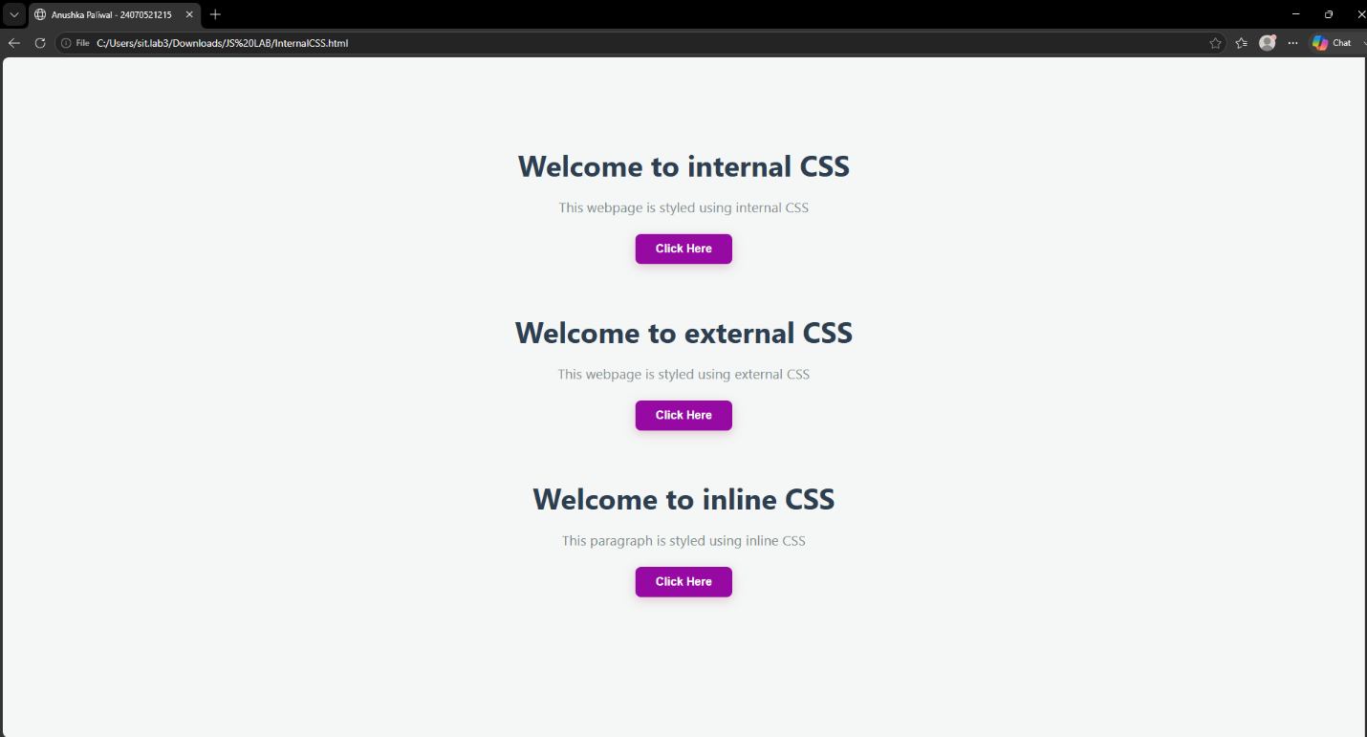
CASE STUDY 1
TITLE:
Interactive Academic Portal: Linking College and Student Information Systems

AIM:
To design and develop a modular, client-side web application using HTML5 and JavaScript that seamlessly links global institutional profiles with dynamic, individual student data validation forms.

SOFTWARE/TECHNOLOGY USED:
- Frontend Structure: HTML5
- Client-Side Scripting: JavaScript (ES6+)
- Styling Language: CSS3
- Development Environment: Visual Studio Code / Notepad++
- Version Control: GitHub Repository System
- Execution Environment: Any modern web browser (Google Chrome, Mozilla Firefox, Microsoft Edge)
PROJECT DISCRIPTION:
This case study implements an interconnected web portal consisting of two main components:
- College.html: Acts as the institutional landing page. It displays general information about the college, infrastructure, courses offered, and contains navigation hooks to access individual student directories.
- StudentInfo.html: A dynamic information portal that captures, processes, and displays specific student data. JavaScript handles the client-side logic, validating text fields, computing form states, and ensuring formatting accuracy before submission.
CODE:
Source Code: college.html
<!DOCTYPE html>
<html lang="en">
<head>
<meta charset="UTF-8">
<meta name="viewport" content="width=device-width, initial-scale=1.0">
<title>Academic Portal - Institutional Profile</title>
<style>
body {
font-family: Arial, sans-serif;
line-height: 1.6;
margin: 20px;
padding: 20px;
background-color: #f4f4f9;
}
header {
background: #003366;
color: #fff;
padding: 20px;
text-align: center;
border-radius: 5px;
}
section {
background: #fff;
margin: 20px 0;
padding: 20px;
border-radius: 5px;
box-shadow: 0 2px 5px rgba(0,0,0,0.1);
}
h2 {
color: #003366;
}
.btn {
display: inline-block;
background: #003366;
color: #fff;
padding: 10px 20px;
text-decoration: none;
border-radius: 5px;
font-weight: bold;
}
.btn:hover {
background: #002244;
}
</style>
</head>
<body>
<header>
<h1>Welcome to the Institutional Portal</h1>
<p>Pranav Lakhe | Case Study 1</p>
</header>
<section id="about">
<h2>About the Institution</h2>
<p>This portal acts as the centralized academic hub managing campus infrastructure, department assignments, and student demographic portfolios.</p>

<section id="departments">
<h2>Courses & Departments</h2>
<ul>
<li>Department of Computer Science & Engineering</li>
<li>Department of Information Technology</li>
<li>Department of Data Science</li>
</ul>

<section id="navigation">
<h2>Student Information Directory</h2>
<p>Access individual student verification forms, check submission integrity, and review registration logs.</p>
<a href="StudentInfo.html" class="btn">Open Student Information Portal &rarr;</a>
</body>
</html>

Source code: student_info.html
<!DOCTYPE html>
<html lang="en">
<head>
<meta charset="UTF-8">
<meta name="viewport" content="width=device-width, initial-scale=1.0">
<title>Student Information Validation Portal</title>
<style>
body {
font-family: Arial, sans-serif;
line-height: 1.6;
margin: 20px;
padding: 20px;
background-color: #f4f4f9;
}
.container {
max-width: 600px;
background: #fff;
margin: auto;
padding: 20px;
border-radius: 5px;
box-shadow: 0 2px 5px rgba(0,0,0,0.1);
}
h2 {
color: #003366;
text-align: center;
}
.form-group {
margin-bottom: 15px;
}
label {
display: block;
margin-bottom: 5px;
font-weight: bold;
}
input[type="text"], select {
width: 100%;
padding: 8px;
box-sizing: border-box;
border: 1px solid #ccc;
border-radius: 4px;
}
button {
background: #003366;
color: white;
padding: 10px 15px;
border: none;
border-radius: 4px;
cursor: pointer;
width: 100%;
font-size: 16px;
}
button:hover {
background: #002244;
}
#outputWindow {
margin-top: 20px;
padding: 15px;
background: #eef2f7;
border-left: 5px solid #003366;
display: none;
}
.back-link {
display: block;
text-align: center;
margin-top: 15px;
color: #003366;
text-decoration: none;
}
</style>
</head>
<body>
<div class="container">
<h2>Student Registration Profile</h2>
<form id="studentForm" onsubmit="return validateForm(event)">
<div class="form-group">
<label for="prn">PRN / Roll Number:</label>
<input type="text" id="prn" placeholder="e.g., 24070521248">
</div>
<div class="form-group">
<label for="fullName">Full Name:</label>
<input type="text" id="fullName" placeholder="e.g., Pranav Lakhe">
</div>
<div class="form-group">
<label for="department">Select Department:</label>
<select id="department">
<option value="">-- Select --</option>
<option value="Computer Science">Computer Science</option>
<option value="Information Technology">Information Technology</option>
<option value="Data Science">Data Science</option>
</select>
</div>
<button type="submit">Submit & Validate Profile</button>
</form>

<div id="outputWindow">
<h3>Submission Profile Summary</h3>
<p><strong>PRN:</strong> <span id="outPrn"></span></p>
<p><strong>Name:</strong> <span id="outName"></span></p>
<p><strong>Department:</strong> <span id="outDept"></span></p>
<p><strong>Status:</strong> Verification Successful ✓</p>
</div>
<a href="College.html" class="back-link">&larr; Return to Institutional Home</a>
</div>
<script>
function validateForm(event) {
event.preventDefault();
var prn = document.getElementById("prn").value.trim();
var fullName = document.getElementById("fullName").value.trim();
var department = document.getElementById("department").value;
if (prn === "" || fullName === "" || department === "") {
alert("Error: All form fields are mandatory and cannot be blank.");
return false;
}
var prnPattern = /^[0-9]+$/;
if (!prnPattern.test(prn)) {
alert("Error: PRN must contain numerical values only.");
return false;
}
document.getElementById("outPrn").innerText = prn;
document.getElementById("outName").innerText = fullName;
document.getElementById("outDept").innerText = department;

document.getElementById("outputWindow").style.display = "block";
return true;
}
</script>
</body>
</html>

OUTPUT:
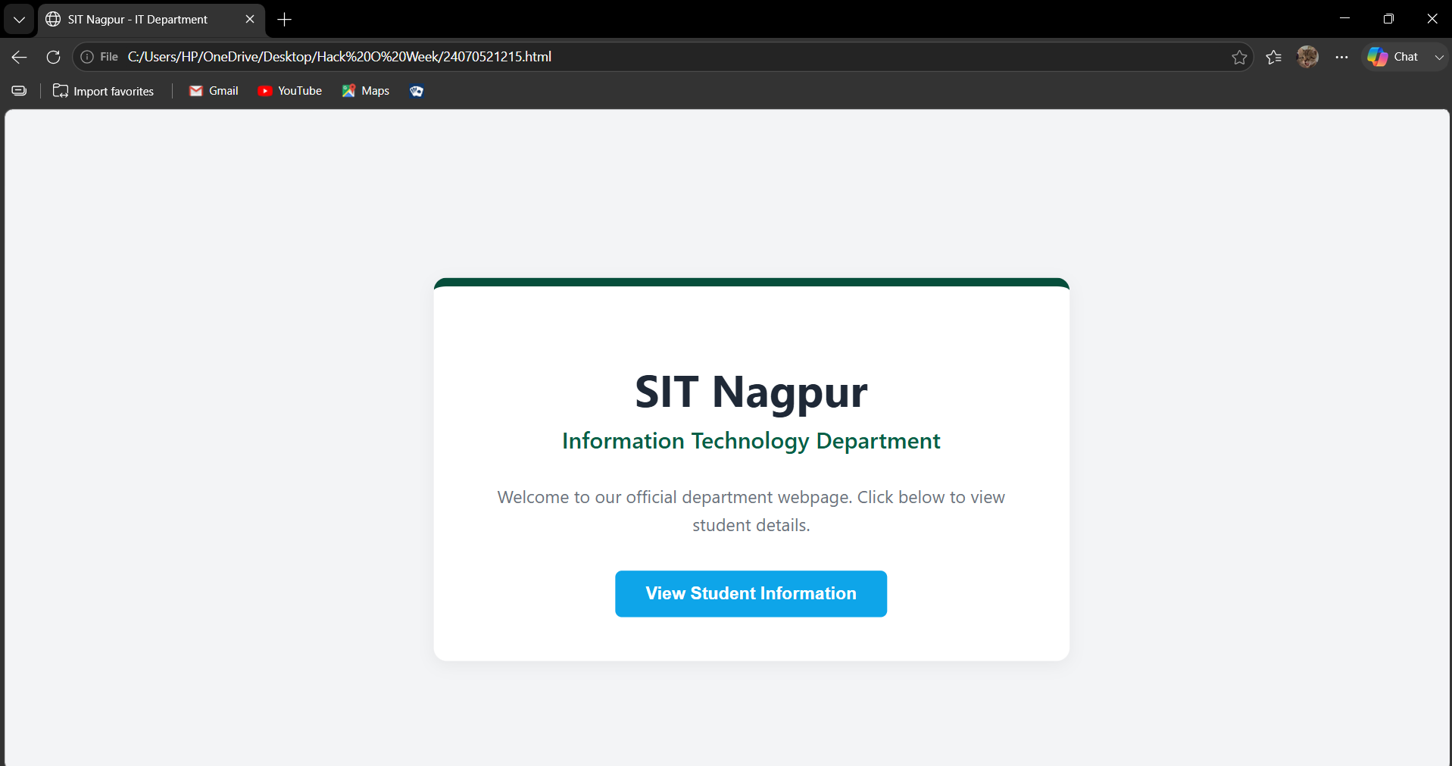

RESULT:
The experiment was successfully completed. The three methods of applying CSS Inline,
Internal, and External CSS were implemented and understood. It was observed that
External CSS is the most efficient and maintainable approach for styling multiple webpages,
while Inline and Internal CSS are useful for small-scale or page-specific styling.

EXPERIMENT 2
AIM:
Use var, let, const, and demonstrate basic features like template literals and
destructuring; build a billing calculator with user input.

SOFTWARE/TOOLS REQUIRED:
Visual Studio Code (or any text editor), Web Browser (Google Chrome, Microsoft Edge, Firefox, etc.)

THEORY:
JavaScript provides three keywords to declare variables: var, let, and const.
Var
- var is function-scoped.
- Variables declared with var can be redeclared and updated.
- It is hoisted and initialized with undefined.
- Generally avoided in modern JavaScript because it may cause unexpected behavior.
Let
- let is block-scoped.
- Variables can be updated but cannot be redeclared within the same scope.
- Preferred for variables whose values change.
Const
- const is also block-scoped.
- Variables cannot be reassigned after initialization.
- Used for fixed values..
Billing Calculator
A billing calculator is a JavaScript application that accepts user input such as customer name,
product name, quantity, and price. It calculates the subtotal, applies any discount or GST if
required, and displays the final payable amount using template literals and modern JavaScript
features like let, const, and destructuring.

OUTPUT:
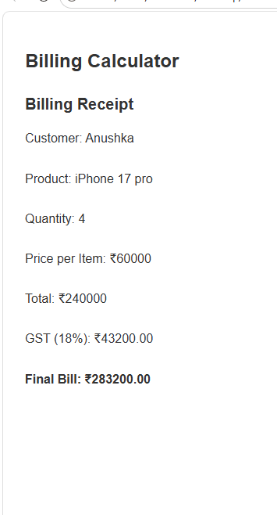

CASE STUDY 2
TITLE:
Automated E-Commerce Billing Engine & Dynamic Invoice Generator

AIM:
To design and develop an interactive, client-side billing application (BILL.HTML) using HTML5, CSS3, and JavaScript (ES6+) that parses real-time product quantities, applies discount thresholds, calculates taxation rates, and renders an itemised invoice directly onto the Document Object Model (DOM).

SOFTWARE AND TECHNOLOGIES USED:
- Frontend Structure: HTML5
- Client-Side Scripting: JavaScript (ES6+)
- Styling Language: CSS3
- Development Environment: Visual Studio Code / Notepad++
- Version Control Sandbox: GitHub Repository Hub
- Execution Environment: Any modern web browser (Google Chrome, Mozilla Firefox, Microsoft Edge)

PROJECT DISCRIPTION:
This case study focuses on building a transactional application centered around BILL.HTML. The application serves as an automated checkout terminal. It captures item pricing, quantities, and customer details, processing them completely on the client side. JavaScript eliminates the need for repeated page reloads or server handshakes by dynamically tracking arithmetic changes, validating numeric constraints, computing subtotal matrices, and generating a clean, printable summary instantly.

CODE:
Source Code: bill.html
<!DOCTYPE html>
<html lang="en">
<head>
<meta charset="UTF-8">
<meta name="viewport" content="width=device-width, initial-scale=1.0">
<title>E-Commerce Automated Billing Engine</title>
<style>
body {
font-family: 'Segoe UI', Tahoma, Geneva, Verdana, sans-serif;
line-height: 1.6;
margin: 0;
padding: 30px;
background-color: #f7f9fc;
}
.billing-container {
max-width: 700px;
background: #ffffff;
margin: auto;
padding: 25px;
border-radius: 8px;
box-shadow: 0 4px 15px rgba(0,0,0,0.05);
}
h2, h3 {
color: #1a365d;
text-align: center;
margin-top: 0;
}
.student-badge {
text-align: center;
font-size: 14px;
color: #718096;
margin-bottom: 25px;
border-bottom: 2px dashed #e2e8f0;
padding-bottom: 10px;
}
.form-row {
display: flex;
gap: 15px;
margin-bottom: 15px;
}
.form-group {
flex: 1;
display: flex;
flex-direction: column;
}
label {
font-weight: 600;
margin-bottom: 6px;
color: #2d3748;
}
input, select {
padding: 10px;
border: 1px solid #cbd5e0;
border-radius: 5px;
font-size: 15px;
}
input:focus, select:focus {
outline: none;
border-color: #3182ce;
}
button {
background: #2b6cb0;
color: #ffffff;
padding: 12px;
border: none;
border-radius: 5px;
cursor: pointer;
width: 100%;
font-size: 16px;
font-weight: bold;
margin-top: 10px;
transition: background 0.2s;
}
button:hover {
background: #2c5282;
}
.invoice-box {
margin-top: 25px;
padding: 20px;
background: #f8fafc;
border: 1px dashed #4299e1;
border-radius: 6px;
display: none;
}
.invoice-table {
width: 100%;
border-collapse: collapse;
margin-top: 15px;
}
.invoice-table th, .invoice-table td {
padding: 10px;
text-align: left;
border-bottom: 1px solid #e2e8f0;
}
.invoice-table th {
background: #edf2f7;
color: #2d3748;
}
.text-right {
text-align: right !important;
}
.total-highlight {
font-size: 18px;
font-weight: bold;
color: #e53e3e;
}
</style>
</head>
<body>
<div class="billing-container">
<h2>E-Commerce Billing System</h2>
<div class="student-badge">Developer: Pranav Lakhe | PRN: 24070521248</div>
<form id="billingForm" onsubmit="generateInvoice(event)">
<div class="form-row">
<div class="form-group">
<label for="customerName">Customer Name:</label>
<input type="text" id="customerName" placeholder="Enter name" required>
</div>
<div class="form-group">
<label for="invoiceNo">Invoice Number:</label>
<input type="text" id="invoiceNo" placeholder="INV-2026-001" required>
</div>
</div>
<div class="form-row">
<div class="form-group" style="flex: 2;">
<label for="itemName">Item Description:</label>
<input type="text" id="itemName" placeholder="Product name/model" required>
</div>
<div class="form-group">
<label for="itemCategory">Category:</label>
<select id="itemCategory">
<option value="Electronics">Electronics (18% GST)</option>
<option value="Clothing">Clothing (5% GST)</option>
<option value="Essentials">Essentials (0% GST)</option>
</select>
</div>
</div>
<div class="form-row">
<div class="form-group">
<label for="unitPrice">Unit Price (₹):</label>
<input type="number" id="unitPrice" step="0.01" min="0" placeholder="0.00" required>
</div>
<div class="form-group">
<label for="quantity">Quantity:</label>
<input type="number" id="quantity" min="1" placeholder="1" required>
</div>
<div class="form-group">
<label for="discountRate">Discount (%):</label>
<input type="number" id="discountRate" min="0" max="100" placeholder="0">
</div>
</div>
<button type="submit">Compute Calculations & Generate Receipt</button>
</form>
<div id="invoiceBox" class="invoice-box">
<h3>RETAIL INVOICE RECEIPT</h3>
<p><strong>Customer Reference:</strong> <span id="invCustomer"></span><br>
<strong>Invoice String ID:</strong> <span id="invId"></span></p>
<table class="invoice-table">
<thead>
<tr>
<th>Item Description</th>
<th class="text-right">Rate</th>
<th class="text-right">Qty</th>
<th class="text-right">Subtotal</th>
</tr>
</thead>
<tbody>
<tr>
<td><span id="invItem"></span> (<span id="invCat"></span>)</td>
<td class="text-right">₹<span id="invPrice"></span></td>
<td class="text-right"><span id="invQty"></span></td>
<td class="text-right">₹<span id="invSub"></span></td>
</tr>
<tr>
<td colspan="3" class="text-right">Discount Applied:</td>
<td class="text-right" style="color: #38a169;">-₹<span id="invDisc"></span></td>
</tr>
<tr>
<td colspan="3" class="text-right">Calculated Tax Component (GST):</td>
<td class="text-right">₹<span id="invTax"></span></td>
</tr>
<tr style="background: #f7fafc;">
<td colspan="3" class="text-right <strong>total-highlight</strong>">Grand Total Payable:</td>
<td class="text-right total-highlight">₹<span id="invGrand"></span></td>
</tr>
</tbody>
</table>
</div>
</div>
<script>
function generateInvoice(event) {
event.preventDefault();
// 1. Data Capture Extractors
var customer = document.getElementById("customerName").value.trim();
var invoiceNum = document.getElementById("invoiceNo").value.trim();
var item = document.getElementById("itemName").value.trim();
var category = document.getElementById("itemCategory").value;
var price = parseFloat(document.getElementById("unitPrice").value);
var qty = parseInt(document.getElementById("quantity").value);
var discRate = parseFloat(document.getElementById("discountRate").value) || 0;
// 2. Arithmetic Matrix Calculations
var rawSubtotal = price * qty;
var discountAmount = (discRate / 100) * rawSubtotal;
var discountedSubtotal = rawSubtotal - discountAmount;
// Tax Percentage Matrix Assignment
var taxPercentage = 0;
if (category === "Electronics") taxPercentage = 18;
else if (category === "Clothing") taxPercentage = 5;
else if (category === "Essentials") taxPercentage = 0;
var taxAmount = (taxPercentage / 100) * discountedSubtotal;
var grandTotal = discountedSubtotal + taxAmount;
// 3. UI Node Rendering Updates
document.getElementById("invCustomer").innerText = customer;
document.getElementById("invId").innerText = invoiceNum;
document.getElementById("invItem").innerText = item;
document.getElementById("invCat").innerText = category;
document.getElementById("invPrice").innerText = price.toFixed(2);
document.getElementById("invQty").innerText = qty;
document.getElementById("invSub").innerText = rawSubtotal.toFixed(2);
document.getElementById("invDisc").innerText = discountAmount.toFixed(2);
document.getElementById("invTax").innerText = taxAmount.toFixed(2);
document.getElementById("invGrand").innerText = grandTotal.toFixed(2);
// Slide/Toggle element block presence configurations
document.getElementById("invoiceBox").style.display = "block";
}
</script>
</body>
</html>

OUTPUT:
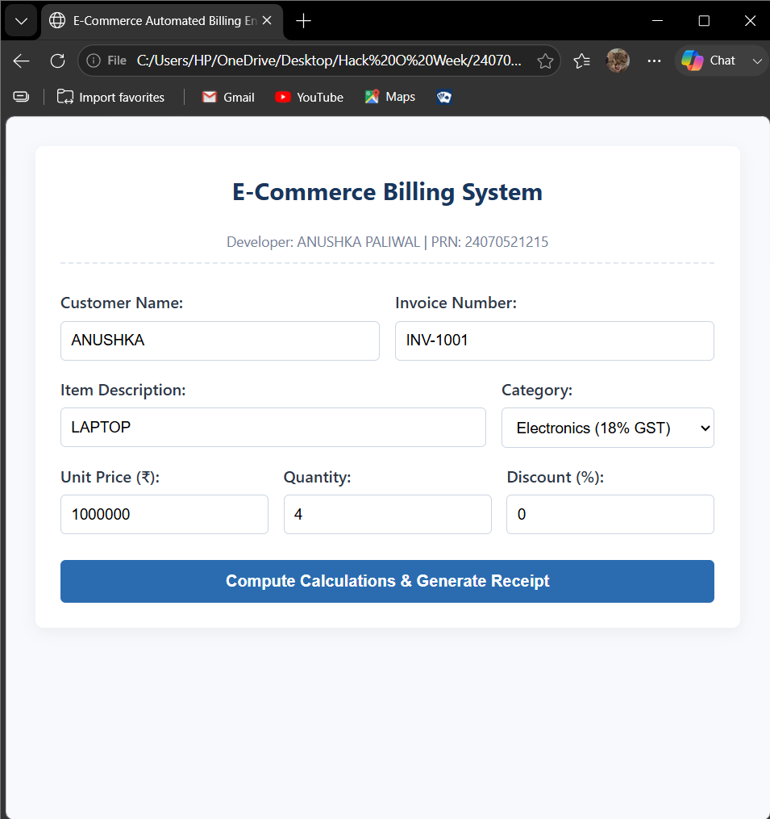

RESULT:
The experiment was successfully completed. The concepts of var, let, and const were
understood and implemented. Template literals were used to display formatted output, and
destructuring simplified data extraction from objects. A billing calculator was successfully
developed to accept user input, calculate the bill with GST, and display the final amount
accurately.

EXPERIMENT 3
AIM:
Implement control structures and form validation; create a grading system based on
user-entered marks.

SOFTWARE AND TOOLS REQUIRED:
Visual Studio Code (or any text editor), Web Browser (Google Chrome, Microsoft Edge, Firefox, etc.)

THEORY:
JavaScript provides different control structures and variable declaration methods to build
interactive web applications.
if-else Statement
- Used to make decisions based on conditions.
- Executes different blocks of code depending on whether the condition is true or false.
switch Statement
- Used when multiple conditions need to be checked.
- Executes the matching case based on the given expression.
Loops
- for: Repeats code for a fixed number of iterations.
- while: Repeats code while a condition is true.
- do-while: Executes the code at least once before checking the condition.

Form Validation
- Ensures that user inputs are valid before processing.
- Checks for empty fields, valid ranges, and correct data types.
Student Grading System
A Student Grading System is a JavaScript application that accepts student details and marks,
validates the input, calculates the total and percentage, assigns grades using control
structures, and displays the final result dynamically.

OUTPUT:
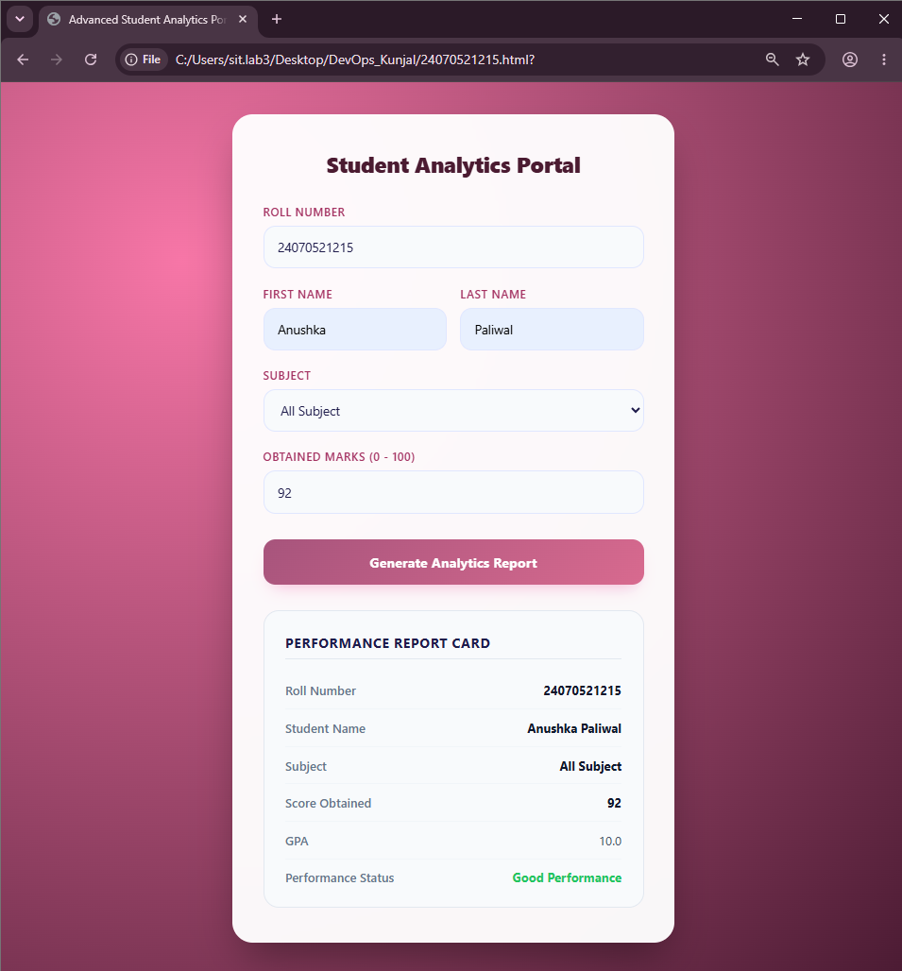
CASE STUDY 3
TITLE:
Automated Academic Scholarship Evaluation & Eligibility Matrix Engine.

AIM:
To design and implement a client-side decision-logic web application (ScholorshipEligibility.html) using HTML5, CSS3, and JavaScript conditional structures that parses academic scores, annual family income thresholds, and demographic parameters to determine student scholarship validation matrix states instantly.

SOFTWARE AND TOOLS REQUIRED:
- Frontend Structure: HTML5
- Client-Side Scripting: JavaScript (ES6+)
- Styling Language: CSS3
- Development Environment: Visual Studio Code / Notepad++
- Version Control Sandbox: GitHub Repository Hub
- Execution Environment: Any modern web browser (Google Chrome, Mozilla Firefox, Microsoft Edge)

PROJECT DISCRIPTION:
This case study implements a rule-based engine encapsulated within ScholorshipEligibility.html. The system collects student credentials including academic performance marks, cumulative family income values, and specific category enrollment selectors. JavaScript computes nested verification layers in real-time, matching student profiles against standard institutional scholarship matrices without triggering server-side script transactions.

CODE:
Source code: scholarship_eligibility.html
<!DOCTYPE html>
<html lang="en">
<head>
<meta charset="UTF-8">
<meta name="viewport" content="width=device-width, initial-scale=1.0">
<title>Academic Scholarship Eligibility Portal</title>
<style>
body {
font-family: 'Segoe UI', Tahoma, Geneva, Verdana, sans-serif;
line-height: 1.6;
margin: 0;
padding: 30px;
background-color: #f0f4f8;
}
.scholarship-container {
max-width: 650px;
background: #ffffff;
margin: auto;
padding: 30px;
border-radius: 8px;
box-shadow: 0 4px 20px rgba(0,0,0,0.08);
}
h2, h3 {
color: #1a365d;
text-align: center;
margin-top: 0;
}
.developer-badge {
text-align: center;
font-size: 14px;
color: #4a5568;
margin-bottom: 25px;
border-bottom: 2px solid #e2e8f0;
padding-bottom: 12px;
}
.form-group {
display: flex;
flex-direction: column;
margin-bottom: 18px;
}
label {
font-weight: 600;
margin-bottom: 6px;
color: #2d3748;
}
input, select {
padding: 10px;
border: 1px solid #cbd5e0;
border-radius: 5px;
font-size: 15px;
}
input:focus, select:focus {
outline: none;
border-color: #4c51bf;
box-shadow: 0 0 0 3px rgba(76,81,191,0.1);
}
button {
background: #4c51bf;
color: #ffffff;
padding: 12px;
border: none;
border-radius: 5px;
cursor: pointer;
width: 100%;
font-size: 16px;
font-weight: bold;
transition: background 0.2s;
}
button:hover {
background: #434190;
}
.result-panel {
margin-top: 25px;
padding: 20px;
border-radius: 6px;
display: none;
}
.approved {
background-color: #f0fff4;
border: 1px solid #38a169;
color: #276749;
}
.rejected {
background-color: #fff5f5;
border: 1px solid #e53e3e;
color: #9b2c2c;
}
</style>
</head>
<body>

<div class="scholarship-container">
<h2>Scholarship Eligibility Portal</h2>
<div class="developer-badge">Developer: Pranav Lakhe | PRN: 24070521248</div>

<form id="eligibilityForm" onsubmit="evaluateEligibility(event)">
<div class="form-group">
<label for="studentName">Student Full Name:</label>
<input type="text" id="studentName" placeholder="Enter complete name" required>
</div>

<div class="form-group">
<label for="academicScore">Academic Score (Percentage / Aggregate):</label>
<input type="number" id="academicScore" min="0" max="100" step="0.1" placeholder="e.g., 85.5" required>
</div>

<div class="form-group">
<label for="familyIncome">Annual Family Income (₹):</label>
<input type="number" id="familyIncome" min="0" placeholder="e.g., 450000" required>
</div>

<div class="form-group">
<label for="scholarshipType">Select Scholarship Scheme:</label>
<select id="scholarshipType">
<option value="merit">Merit-Based Scheme (Min Marks: 85%, Max Income: ₹8,00,000)</option>
<option value="need">EBC Financial Assistance (Min Marks: 60%, Max Income: ₹3,00,000)</option>
<option value="special">Special Talent Grant (Min Marks: 75%, Max Income: ₹6,00,000)</option>
</select>
</div>

<button type="submit">Execute Logic & Check Eligibility</button>
</form>

<div id="resultPanel" class="result-panel">
<h3 id="resultTitle">Evaluation Status</h3>
<p><strong>Candidate Name:</strong> <span id="resName"></span></p>
<p><strong>Scheme Checked:</strong> <span id="resScheme"></span></p>
<p id="resDetails"></p>
</div>
</div>

<script>
function evaluateEligibility(event) {
event.preventDefault();

// 1. Parameter Extraction
var name = document.getElementById("studentName").value.trim();
var score = parseFloat(document.getElementById("academicScore").value);
var income = parseFloat(document.getElementById("familyIncome").value);
var scheme = document.getElementById("scholarshipType").value;

var isEligible = false;
var schemeName = "";
var feedbackMessage = "";

// 2. Multi-Tiered Conditional Matrix Analysis
if (scheme === "merit") {
schemeName = "Merit-Based Scholarship Scheme";
if (score >= 85 && income <= 800000) {
isEligible = true;
feedbackMessage = "Congratulations! Profile cleared the structural academic and economic baseline thresholds.";
} else {
feedbackMessage = "Status Denied: Requires a minimum score of 85% and family income within ₹8,00,000.";
}
} else if (scheme === "need") {
schemeName = "EBC Financial Assistance Scheme";
if (score >= 60 && income <= 300000) {
isEligible = true;
feedbackMessage = "Congratulations! Profile qualified under the high-priority financial necessity category.";
} else {
feedbackMessage = "Status Denied: Requires a minimum score of 60% and family income restricted to ₹3,00,000.";
}
} else if (scheme === "special") {
schemeName = "Special Talent Advancement Grant";
if (score >= 75 && income <= 600000) {
isEligible = true;
feedbackMessage = "Congratulations! Candidate confirmed eligible for the specialized department allowance.";
} else {
feedbackMessage = "Status Denied: Requires a minimum score of 75% and family income within ₹6,00,000.";
}
}

// 3. UI Node State Modification
document.getElementById("resName").innerText = name;
document.getElementById("resScheme").innerText = schemeName;
document.getElementById("resDetails").innerText = feedbackMessage;

var panel = document.getElementById("resultPanel");
panel.style.display = "block";

// Dynamic status block formatting rules
if (isEligible) {
panel.className = "result-panel approved";
document.getElementById("resultTitle").innerText = "ELIGIBILITY VERIFIED ✓";
} else {
panel.className = "result-panel rejected";
document.getElementById("resultTitle").innerText = "ELIGIBILITY REJECTED ✗";
}
}
</script>
</body>
</html>

OUTPUT:
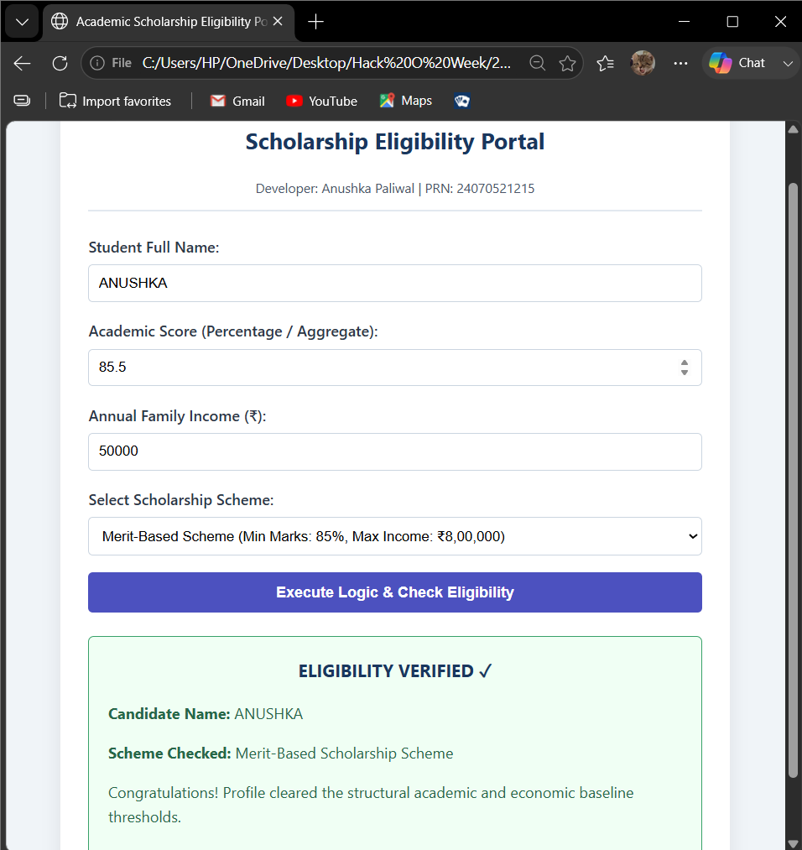

RESULT:
The experiment was successfully completed. The concepts of var, let, and const were
understood and implemented. Template literals were used to display formatted output, and
destructuring simplified data extraction from objects. A billing calculator was successfully
developed to accept user input, calculate the bill with GST, and display the final amount
accurately.

EXPERIMENT 4
AIM:
Use function types, scope, and closures; apply try-catch; build a palindrome checker.

SOFTWARE AND TOOLS REQUIRED:
- Any text/code editor (e.g., VS Code)
- Web browser (e.g., Chrome, Edge, Firefox) to render the HTML page
- Basic knowledge of HTML5 and modern JavaScript (ES6+)
THEORY:
JavaScript Functions
Functions are reusable blocks of code designed to perform a specific task. JavaScript supports
different types of functions:
- Function Declaration: A named function that can be called before its definition due to hoisting.
- Function Expression: A function assigned to a variable, executed only after initialization.
- Arrow Function: A concise ES6 syntax for writing functions, especially useful for callbacks and short functions.
Variable Scope
Scope determines where variables can be accessed.
- Global Scope: Variables declared outside functions are accessible throughout the program.
- Function Scope: Variables declared using var inside a function are accessible only within that function.
- Block Scope: Variables declared with let and const are limited to the block ({}) in which they are defined.

Closures
A closure is created when an inner function retains access to the variables of its outer function
even after the outer function has finished execution. Closures are commonly used for data
encapsulation, private variables, and maintaining state.

Exception Handling (try-catch)
The try-catch statement allows JavaScript programs to handle runtime errors gracefully. The
try block contains code that may generate an error, while the catch block executes if an
exception occurs, preventing the application from crashing.

Experiment Context
This experiment involves creating an interactive Palindrome Checker. The application
accepts a string from the user and determines whether it is a palindrome. It demonstrates
different function types for processing input, uses variable scope effectively, implements
closures to preserve internal state, and applies try-catch to handle invalid or unexpected user
input.

OUTPUT:
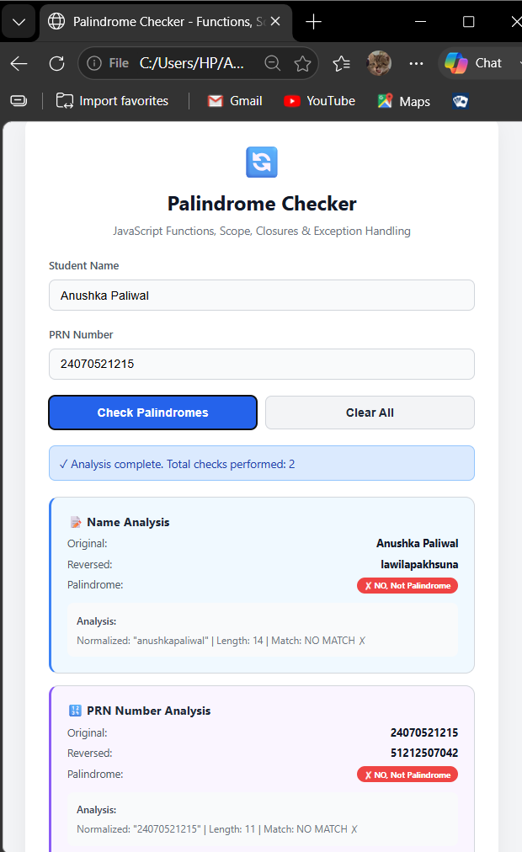
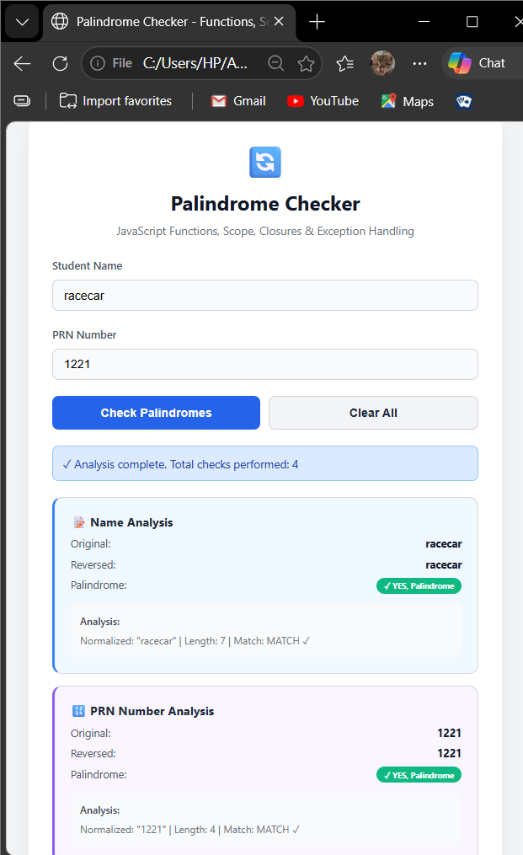

CASE STUDY 4
TITLE:
Modern Multi-Theme Task Manager & Interactive To-Do Application

AIM:
To design and implement a decoupled, state-driven front-end web application (index.html, style.css, script.js) that enables dynamic task lifecycle operations (creation, completion filtering, and purging) alongside an active runtime theme modification switch.

THEORY:
- Frontend Structure: HTML5 Semantic Markup
- Styling & Layout: CSS3 Layout Engine (Custom Properties, Flexbox)
- Client Scripting: JavaScript (ES6+ Functional Modules, Event Listeners)
- Development Environment: Visual Studio Code / Notepad++
- Version Control Sandbox: GitHub Repository Hub
- Execution Environment: Modern Web Browsers (Chrome, Edge, Firefox)

PROJECT DISCRIPTION:
This case study outlines a structural production environment deployed as a three-file workspace core (index.html, style.css, script.js). The system acts as a responsive Task Management Board. Users can register operational tasks, toggle completion states via inline event binds, and filter structural columns. JavaScript handles internal array mutations locally, updating visibility parameters and controlling runtime appearance stylesheets instantly without requiring page reloads or server transactions.

CODE:
Source code: index.html
<!DOCTYPE html>
<html lang="en">
<head>
<meta charset="UTF-8">
<meta name="viewport" content="width=device-width, initial-scale=1.0">
<title>Dynamic Productivity Board</title>
<link rel="stylesheet" href="style.css">
</head>
<body class="light-theme">
<div class="app-container">
<header class="app-header">
<h1>Workspace Organizer</h1>
<div class="developer-info">Developer: Pranav Lakhe | PRN: 24070521248</div>
<button id="themeToggleBtn" onclick="toggleAppTheme()">Switch to Dark UI</button>
</header>
<main class="main-workspace">
<section class="input-panel">
<input type="text" id="taskInput" placeholder="Add a new goal or milestone..." autocomplete="off">
<button onclick="addNewTask()">Enlist Goal</button>
<section class="filter-controls">
<button class="filter-btn active" onclick="applyTaskFilter('all', this)">All Tasks</button>
<button class="filter-btn" onclick="applyTaskFilter('pending', this)">Active</button>
<button class="filter-btn" onclick="applyTaskFilter('completed', this)">Completed</button>
<ul id="taskListContainer" class="task-list"></ul>
</main>
</div>
<script src="script.js"></script>
</body>
</html>

Source code: style.css
:root {
--bg-main: #f0f4f8;
--bg-card: #ffffff;
--text-primary: #2d3748;
--text-muted: #718096;
--accent: #4c51bf;
--accent-hover: #434190;
--border-color: #cbd5e0;
}

body.dark-theme {
--bg-main: #1a202c;
--bg-card: #2d3748;
--text-primary: #f7fafc;
--text-muted: #a0aec0;
--accent: #63b3ed;
--accent-hover: #4299e1;
--border-color: #4a5568;
}

body {
background-color: var(--bg-main);
color: var(--text-primary);
font-family: 'Segoe UI', system-ui, sans-serif;
margin: 0;
padding: 40px 20px;
transition: background-color 0.3s, color 0.3s;
}

.app-container {
max-width: 600px;
margin: 0 auto;
background: var(--bg-card);
padding: 30px;
border-radius: 12px;
box-shadow: 0 10px 25px rgba(0,0,0,0.05);
}

.app-header h1 {
margin: 0 0 5px 0;
color: var(--accent);
}

.developer-info {
font-size: 13px;
color: var(--text-muted);
margin-bottom: 15px;
}

#themeToggleBtn {
background: transparent;
border: 1px solid var(--accent);
color: var(--accent);
padding: 6px 12px;
border-radius: 20px;
cursor: pointer;
font-weight: 500;
}

.input-panel {
display: flex;
gap: 10px;
margin: 25px 0 15px 0;
}

.input-panel input {
flex: 1;
padding: 12px;
border: 1px solid var(--border-color);
background: var(--bg-main);
color: var(--text-primary);
border-radius: 6px;
font-size: 15px;
}

.input-panel button {
background: var(--accent);
color: white;
border: none;
padding: 12px 20px;
border-radius: 6px;
cursor: pointer;
font-weight: bold;
}

.filter-controls {
display: flex;
gap: 8px;
margin-bottom: 20px;
}

.filter-btn {
background: transparent;
border: none;
color: var(--text-muted);
padding: 6px 12px;
cursor: pointer;
font-size: 14px;
border-radius: 4px;
}

.filter-btn.active {
background: var(--accent);
color: white;
}

.task-list {
list-style: none;
padding: 0;
margin: 0;
}

.task-item {
display: flex;
justify-content: space-between;
align-items: center;
padding: 12px;
border-bottom: 1px solid var(--border-color);
}

.task-item.done span {
text-decoration: line-through;
color: var(--text-muted);
}

.task-text {
cursor: pointer;
flex: 1;
}

.delete-btn {
background: #e53e3e;
color: white;
border: none;
padding: 4px 10px;
border-radius: 4px;
cursor: pointer;
}

Source code: script.js
let taskItemsStorage = [];
let currentDisplayFilter = 'all';

function addNewTask() {
const inputField = document.getElementById("taskInput");
const rawText = inputField.value.trim();

if (rawText === "") {
alert("Action Required: Please specify a task description before submission.");
return;
}

const uniqueTaskObject = {
id: Date.now(),
text: rawText,
isCompleted: false
};

taskItemsStorage.push(uniqueTaskObject);
inputField.value = "";
renderTaskElementsTree();
}

function toggleTaskState(id) {
taskItemsStorage = taskItemsStorage.map(item => {
if (item.id === id) {
return { ...item, isCompleted: !item.isCompleted };
}
return item;
});
renderTaskElementsTree();
}

function deleteTaskRecord(id) {
taskItemsStorage = taskItemsStorage.filter(item => item.id !== id);
renderTaskElementsTree();
}

function applyTaskFilter(filterMode, activeBtn) {
currentDisplayFilter = filterMode;

document.querySelectorAll(".filter-btn").forEach(btn => {
btn.classList.remove("active");
});
activeBtn.classList.add("active");

renderTaskElementsTree();
}

function renderTaskElementsTree() {
const outputContainer = document.getElementById("taskListContainer");
outputContainer.innerHTML = "";

const targetedRows = taskItemsStorage.filter(item => {
if (currentDisplayFilter === 'pending') return !item.isCompleted;
if (currentDisplayFilter === 'completed') return item.isCompleted;
return true;
});

targetedRows.forEach(item => {
const itemLi = document.createElement("li");
itemLi.className = `task-item ${item.isCompleted ? 'done' : ''}`;

const textSpan = document.createElement("span");
textSpan.className = "task-text";
textSpan.innerText = item.text;
textSpan.onclick = () => toggleTaskState(item.id);

const deleteButton = document.createElement("button");
deleteButton.className = "delete-btn";
deleteButton.innerText = "Remove";
deleteButton.onclick = () => deleteTaskRecord(item.id);

itemLi.appendChild(textSpan);
itemLi.appendChild(deleteButton);
outputContainer.appendChild(itemLi);
});
}

function toggleAppTheme() {
const bodyNode = document.body;
const actionBtn = document.getElementById("themeToggleBtn");

if (bodyNode.classList.contains("light-theme")) {
bodyNode.classList.replace("light-theme", "dark-theme");
actionBtn.innerText = "Switch to Light UI";
} else {
bodyNode.classList.replace("dark-theme", "light-theme");
actionBtn.innerText = "Switch to Dark UI";
}
}

OUTPUT:
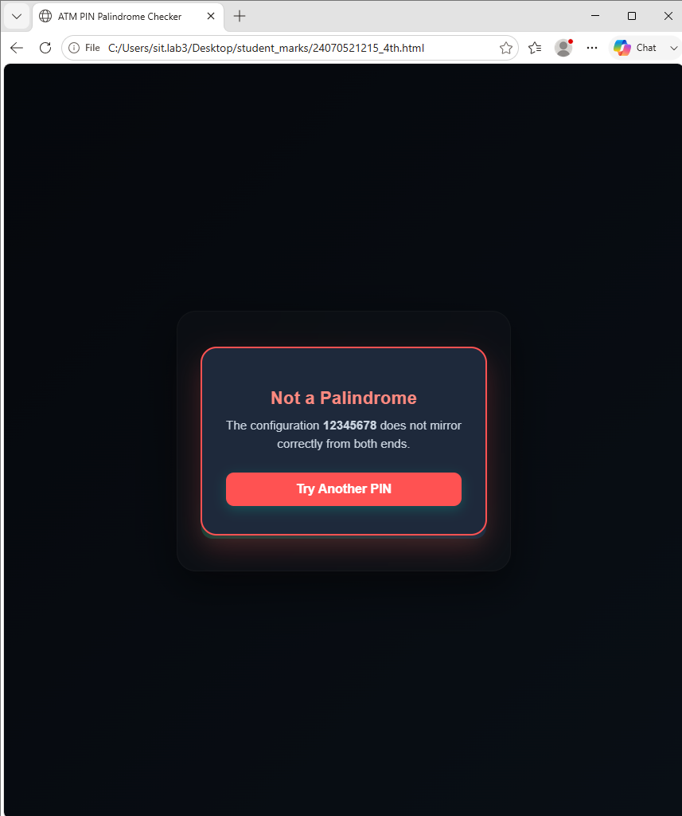
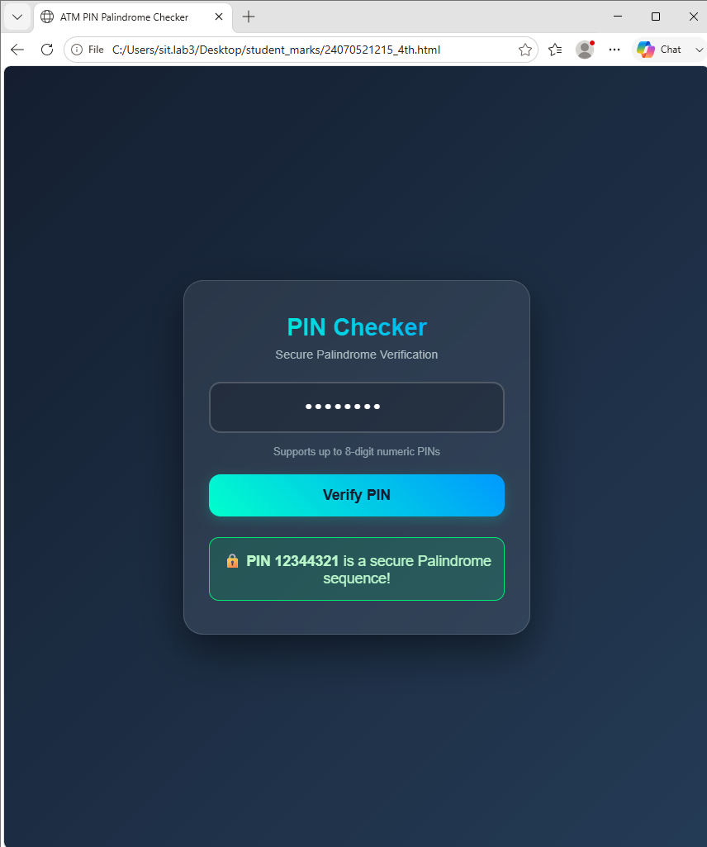
RESULT:
The webpage was successfully created and executed. The output verifies the correct
implementation of JavaScript function types, variable scope, and closures. The experiment
also demonstrates effective exception handling using try-catch and successfully validates user
input to determine whether the entered string is a palindrome, showcasing the practical
application of modern JavaScript programming concepts.

EXPERIMENT 5
AIM:
Apply array methods and object handling; create a cart total calculator with discount logic.

SOFTWARE/TOOLS REQUIRED:
- Any text/code editor (e.g., VS Code)
- Web browser (e.g., Chrome, Edge, Firefox) to render the HTML page
- Basic knowledge of HTML5 and modern JavaScript (ES6+)

THEORY:
- JavaScript Arrays:
Arrays are used to store multiple values in a single variable. They help in managing collections of data and provide various built-in methods for processing and manipulating elements efficiently.
- Array Methods:
JavaScript provides methods like map(), reduce(), filter(), and forEach() to perform operations on array data. These methods simplify tasks such as calculating totals, filtering items, and processing multiple values.
- JavaScript Objects:
Objects store data in the form of key-value pairs and are used to represent real-world entities like products and customers. Object handling allows easy access and management of stored information.
- Discount Logic:
Discount logic is used to automatically calculate price reductions based on predefined conditions. It helps generate accurate final amounts by applying discounts to the total cart value.

EXPERIMENT CONTEXT:
This experiment focuses on creating a cart total calculator using JavaScript arrays and objects. The application processes product details, calculates the total amount, applies discount rules, and displays the final bill dynamically.

OUTPUT:
The Cart Total Calculator & Discount Logic webpage was successfully displayed. It calculates product totals, applies discount coupons, and shows the final bill with subtotal, discount, tax, and total amount dynamically.
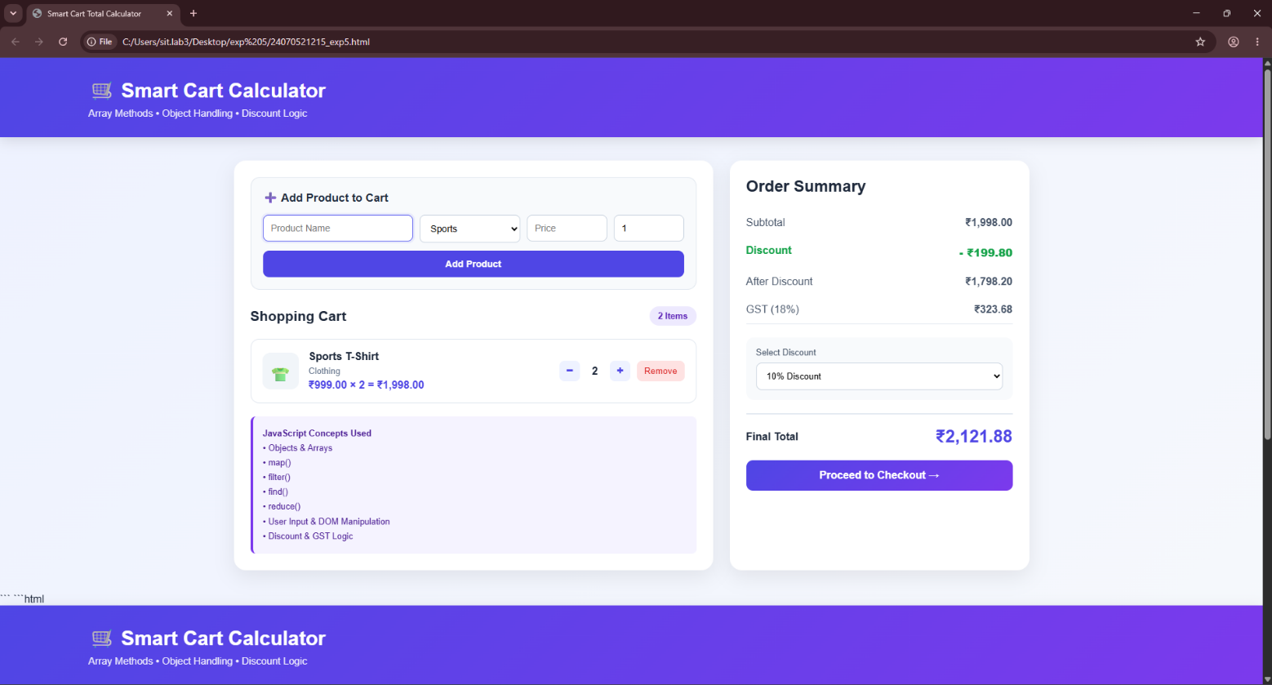

RESULT / CONCLUSION:
The experiment was successfully executed. It demonstrates the use of JavaScript arrays, array methods, object handling, and discount logic for creating a functional shopping cart application.

CASE STUDY 5
TITLE:
Interactive Array Manipulation and Extremum (Max/Min) Finder Web Application

AIM:
To design and develop an interactive, web-based tool using HTML, CSS, and JavaScript that demonstrates fundamental JavaScript array manipulation methods (push, pop, shift, unshift, splice, slice) and dynamically computes the maximum and minimum values in real time.

THEORY:
Arrays in JavaScript are ordered collections used to store multiple values in a single variable. Manipulating arrays effectively requires understanding both mutating and non-mutating operations:
- Queue & Stack Operations:
  - push(): Appends an element to the end of an array (mutates original).
  - pop(): Removes and returns the last element (mutates original).
  - unshift(): Inserts an element at the beginning of an array (mutates original).
  - shift(): Removes and returns the first element (mutates original).
- Index-Based Manipulation:
  - splice(start, deleteCount, ...items): Modifies the array in place by removing, replacing, or inserting elements at a specific index.
  - slice(start, end): Extracts a shallow copy of a portion of an array without modifying the original array (the project reassigns the sliced result back to the current array).
- Extremum Calculation:
  - Math.max(...arr) and Math.min(...arr): Leverage the ES6 spread operator (...) to expand array elements as individual arguments into JavaScript's built-in mathematical extremum functions.

PROJECT DESCRIPTION:
The project is a front-end single-page application (SPA) built using vanilla HTML5, CSS3, and JavaScript.
- User Interface (UI): Features a modern, centered card layout styled with CSS flexbox, gradient backgrounds, responsive form controls, and structured cards for each method.
- Initialization: The user enters a comma-separated list of numbers. The input is sanitized using .split(), .map(parseInt), and .filter() to parse numbers and remove non-numeric entries.
- Dynamic Operations: Individual control blocks provide UI inputs for executing push, pop, shift, unshift, splice, and slice.
- State Management & Output: Every user action triggers a state update function (updateDisplay()) that serializes the current array to JSON for visual inspection, recalculates the maximum and minimum values, and updates the results dashboard dynamically via DOM manipulation.

CODE:
<!DOCTYPE html>
<html lang="en">
<head>
<meta charset="UTF-8" />
<meta name="viewport" content="width=device-width, initial-scale=1.0"/>
<title>Array & Loop Neon Studio</title>
<style>
body {
background-color: #0d1b2a;
font-family: 'Arial', sans-serif;
color: #a8dadc;
margin: 0;
padding: 20px;
}

h1 {
text-align: center;
color: #00b4d8;
font-size: 2em;
margin-bottom: 10px;
}

.main-container {
max-width: 900px;
margin: auto;
display: flex;
flex-wrap: wrap;
gap: 20px;
}

.section {
background-color: #1b263b;
border-radius: 15px;
padding: 20px;
flex: 1 1 45%;
box-shadow: 0 0 15px #0077b6;
}

.section h2 {
color: #90e0ef;
font-size: 1.5em;
margin-bottom: 15px;
text-align: center;
}

input[type="number"] {
width: calc(50% - 20px);
padding: 8px;
margin-right: 10px;
border-radius: 8px;
border: 2px solid #00b4d8;
background-color: #f1faee;
color: #222;
font-size: 1em;
}

button {
padding: 8px 15px;
margin: 5px 5px 10px 5px;
border: none;
border-radius: 8px;
background-color: #00b4d8;
color: #fff;
cursor: pointer;
font-weight: bold;
transition: 0.3s;
}

button:hover {
background-color: #0077b6;
}

#arrayDisplay {
margin-top: 10px;
padding: 10px;
background-color: #457b9d;
border-radius: 8px;
font-family: monospace;
font-size: 1.1em;
word-break: break-all;
}

#result {
margin-top: 15px;
font-size: 1.3em;
font-weight: bold;
text-align: center;
color: #ffd166;
}

.buttons-container {
display: flex;
flex-wrap: wrap;
justify-content: center;
}
</style>
</head>
<body>

<h1>ARRAY & LOOP NEON STUDIO</h1>
<div class="main-container">

<!-- Array Operations Section -->
<div class="section">
<h2>Mutations & Operations</h2>
<input type="number" id="numberInput" placeholder="Enter number" />

<div class="buttons-container">
<button onclick="pushNumber()">Push</button>
<button onclick="popNumber()">Pop</button>
<button onclick="unshiftNumber()">Unshift</button>
<button onclick="spliceNumber()">Splice</button>
</div>

<div id="arrayDisplay">Array: []</div>
<button style="width: 100%; margin-top:10px" onclick="calculateMaxMin()">Find Max & Min</button>
<div id="result"></div>
</div>

</div>

<script>
let arr = [];

function updateDisplay() {
document.getElementById('arrayDisplay').innerHTML = `Array: [${arr.join(', ')}]`;
}

function pushNumber() {
const num = parseFloat(document.getElementById('numberInput').value);
if (!isNaN(num)) {
arr.push(num);
updateDisplay();
}
document.getElementById('numberInput').value = '';
}

function popNumber() {
arr.pop();
updateDisplay();
}

function unshiftNumber() {
const num = parseFloat(document.getElementById('numberInput').value);
if (!isNaN(num)) {
arr.unshift(num);
updateDisplay();
}
document.getElementById('numberInput').value = '';
}

function spliceNumber() {
const num = parseFloat(document.getElementById('numberInput').value);
if (!isNaN(num)) {
// Replace element at index 1 if exists, else add at start
if (arr.length >= 1) {
arr.splice(1, 1, num);
} else {
arr.splice(0, 0, num);
}
updateDisplay();
}
document.getElementById('numberInput').value = '';
}

function calculateMaxMin() {
if (arr.length === 0) {
document.getElementById('result').innerHTML = 'Array is empty!';
return;
}
const max = Math.max(...arr);
const min = Math.min(...arr);
document.getElementById('result').innerHTML = `Max: <b>${max}</b> & Min: <b>${min}</b>`;
}
</script>

</body>
</html>

OUTPUT:
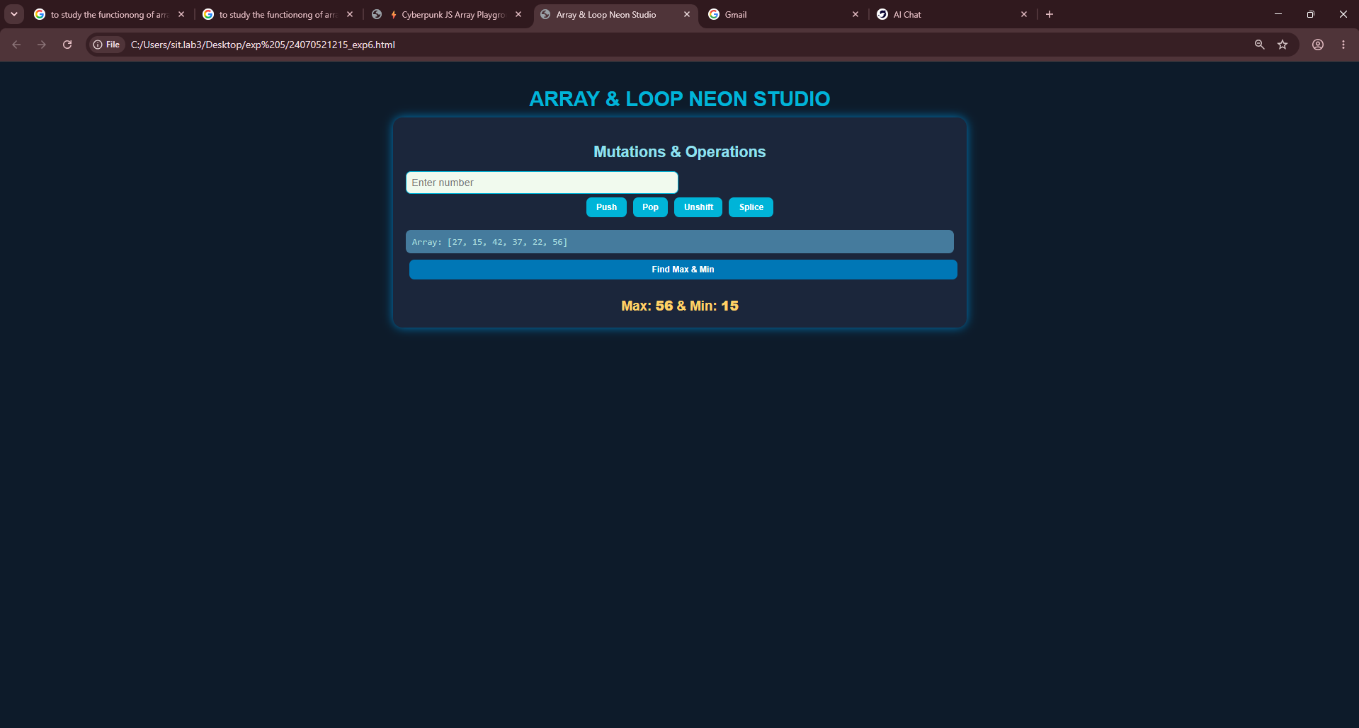
RESULT / CONCLUSION:
Successful Implementation: The web application successfully initializes dynamic numeric arrays from user input and allows real-time execution of array methods (push, pop, shift, unshift, splice, and slice).
Accurate Extremum Detection: The system correctly identifies and updates the maximum and minimum values instantly after every array modification using JavaScript's Math.max() and Math.min().
User Experience: The interactive UI provides immediate visual feedback, making it an effective educational demonstration of how mutating and non-mutating array operations alter data in memory.

EXPERIMENT 6
AIM:
Use string functions and regex for email validation, data extraction, and text analysis.

SOFTWARE REQUIRED:
- Any text/code editor (e.g., VS Code)
- Web browser (e.g., Chrome, Edge, Firefox) to render the HTML page
- Basic knowledge of HTML5 and modern JavaScript (ES6+)

THEORY:
JavaScript String Functions:
String functions are used to perform operations on textual data. They help in searching, extracting, modifying, and analyzing characters and words within a string.

Regular Expressions (Regex):
Regular Expressions are patterns used to search, match, and validate specific types of text. They are useful for identifying data such as email addresses, phone numbers, URLs, tags, and other structured information.
Email Validation:
Email validation uses Regular Expressions to check whether an entered email address follows a valid email format. It helps identify valid email addresses from textual input.
Data Extraction:
Data extraction involves identifying and retrieving specific information from unstructured text. Regex patterns and string methods can be used to extract email addresses, URLs, phone numbers, tags, and other entities from the given text.
Text Analysis:
Text analysis is the process of examining textual content to obtain useful information such as word count, character count, sentences, paragraphs, reading time, character distribution, and keyword frequency.

EXPERIMENT CONTEXT:
This experiment focuses on developing an interactive String Functions & Regex Studio using JavaScript. The application performs email validation, extracts entities from unstructured text, applies string operations, tests regular expressions, and analyzes textual data. It also displays email presence, detected email addresses, word and character counts, sentence and paragraph counts, reading time, character-set distribution, and keyword frequencies dynamically.

OUTPUT:
The String Functions & Regex Studio webpage was successfully displayed. It performs email validation, extracts email addresses and other entities, applies string functions and regular expressions, and analyzes the given text dynamically. The webpage displays the detected mail status, extracted email addresses, text statistics, character-set distribution, and top keyword frequencies.

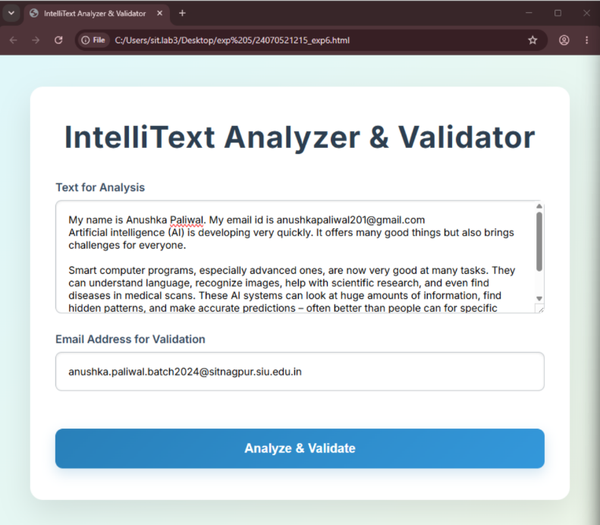
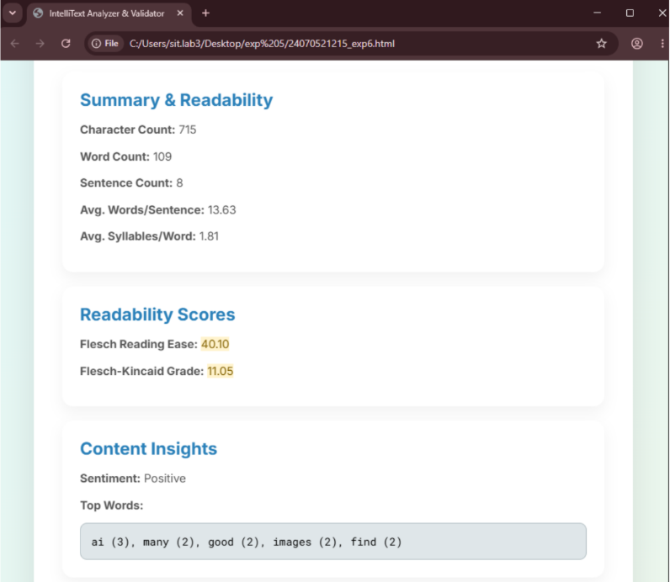
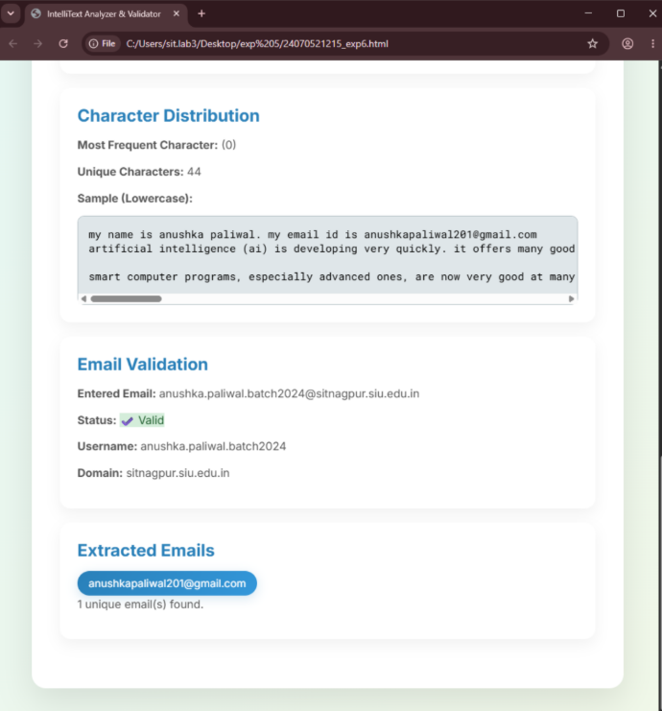

RESULT / CONCLUSION:
The experiment was successfully executed. It demonstrates the use of JavaScript string functions and Regular Expressions for email validation, data extraction, text processing, and analysis of unstructured textual data.

CASE STUDY 6
TITLE:
Interactive Client-Side Data Processing & Form Event Handling Web Application

AIM:
To design and build an interactive web page that demonstrates core front-end concepts: string manipulation (reversing a string), text parsing and character counting (vowel frequency), and DOM event handling (preventing default form submissions and displaying dynamic feedback).

THEORY:
String Manipulation (split().reverse().join()):
- split(''): Breaks the string into an array of individual characters.
- reverse(): Reverses the elements within the array in place.
- join(''): Combines the reversed array elements back into a single string.
Text Analysis & Character Traversal:
- String normalization with toLowerCase() ensures case-insensitive matching.
- The for...of loop traverses the text character-by-character.
- String.prototype.includes() evaluates whether each character is present in the vowel reference string 'aeiou', incrementing a counter upon a match ($O\left(n\right)$ time complexity).
DOM Event Handling & Form Control:
- addEventListener('submit', ...): Registers an event listener on the form element.
- e.preventDefault(): Halts the browser's default behavior (which refreshes or navigates away upon form submission), enabling seamless Single-Page Application (SPA) behavior.
- Dynamic DOM updates are performed via .innerText and ES6 template literals (${...}).

PROJECT DESCRIPTION:
The application is modularized into three distinct interactive sections:
- String Reverser Module:
  - Contains a single-line text field and a button triggering reverseString().
  - Reads the user input, performs array chaining to reverse the sequence, and dynamically prints the reversed result.
- Vowel Frequency Counter Module:
  - Features a multiline <textarea> for bulk text input.
  - On clicking "Count Vowels", countVowels() converts the content to lowercase and tallies every occurrence of a, e, i, o, and u.
- Form Event Demonstration Module:
  - Implements a standard form collecting a user's name and email with HTML5 validation constraints (required, type="email").
  - Intercepts the submit event via JavaScript, suppresses page reload, captures values, and renders an on-page acknowledgment message.

CODE:
<!DOCTYPE html>
<html lang="en">
<head>
<meta charset="UTF-8" />
<meta name="viewport" content="width=device-width, initial-scale=1.0"/>
<title>JavaScript Case Study</title>
<style>
body {
font-family: Arial, sans-serif;
margin: 20px;
background-color: #f0f8ff;
}
h2 {
color: #333;
}
section {
margin-bottom: 30px;
background-color: #ffffff;
padding: 15px;
border-radius: 8px;
box-shadow: 0 0 10px rgba(0,0,0,0.1);
}
input[type="text"], textarea {
width: 100%;
padding: 8px;
margin-top: 8px;
margin-bottom: 12px;
border: 1px solid #ccc;
border-radius: 4px;
}
button {
background-color: #4CAF50;
color: white;
padding: 8px 12px;
border: none;
border-radius: 4px;
cursor: pointer;
}
button:hover {
background-color: #45a049;
}
#result {
margin-top: 10px;
font-weight: bold;
}
</style>
</head>
<body>

<h1>JavaScript Case Study</h1>

<!-- Section for reversing a string -->
<section>
<h2>1. Reverse a String</h2>
<input type="text" id="reverseInput" placeholder="Enter a string" />
<button onclick="reverseString()">Reverse</button>
<div id="reverseResult"></div>
</section>

<!-- Section for counting vowels -->
<section>
<h2>2. Count Vowels in Paragraph</h2>
<textarea id="paragraph" rows="5" placeholder="Enter paragraph text"></textarea>
<button onclick="countVowels()">Count Vowels</button>
<div id="vowelCount"></div>
</section>

<!-- Form for demonstrating event handling -->
<section>
<h2>3. Form Event Handling</h2>
<form id="sampleForm">
<label for="name">Name:</label><br/>
<input type="text" id="name" name="name" required /><br/>
<label for="email">Email:</label><br/>
<input type="email" id="email" name="email" required /><br/><br/>
<button type="submit">Submit</button>
</form>
<div id="formMessage"></div>
</section>

<script>
// Function to reverse a string
function reverseString() {
const input = document.getElementById('reverseInput').value;
const reversed = input.split('').reverse().join('');
document.getElementById('reverseResult').innerText = 'Reversed String: ' + reversed;
}

// Function to count vowels in paragraph
function countVowels() {
const paragraph = document.getElementById('paragraph').value.toLowerCase();
const vowels = 'aeiou';
let count = 0;
for (let char of paragraph) {
if (vowels.includes(char)) {
count++;
}
}
document.getElementById('vowelCount').innerText = 'Number of vowels: ' + count;
}

// Event handling for form submission
document.getElementById('sampleForm').addEventListener('submit', function(e) {
e.preventDefault(); // Prevent form from submitting
const name = document.getElementById('name').value;
const email = document.getElementById('email').value;
document.getElementById('formMessage').innerText = `Thank you, ${name}! Your email (${email}) has been received.`;
});
</script>

</body>
</html>

RESULT / CONCLUSION:
Operational Status: All three JavaScript modules run entirely client-side without external dependencies, processing input instantaneously.
Key Takeaway: Demonstrates essential JavaScript fundamentals including functional array transformations, string processing, state extraction from form controls, and asynchronous/event-driven DOM updates.

EXPERIMENT 7
AIM:
Perform DOM traversal and updates; develop a to-do list app with add, edit, and delete features.

SOFTWARE REQUIRED:
- Visual Studio Code (VS Code)
- Google Chrome

THEORY:
This experiment explores the Document Object Model (DOM) interface, focusing on structural traversal, dynamic element manipulation, and event handling within a web application. The core theoretical pillars implemented include:
- Dynamic DOM Tree Manipulation: The application utilizes methods such as document.getElementById() to fetch container components and document.createElement() to construct new elements structurally. Data insertion and node updates are executed dynamically using properties like innerHTML, appendChild(), and replaceChild().
- DOM Traversal: To target related elements across complex interactions, the script implements structural traversal properties like parentElement. This allows child nodes (such as target click buttons) to cleanly identify and alter their parent list item containers (<li>) without relying on hardcoded unique identifiers.
- Event Delegation: Instead of attaching discrete event listeners to every single button added to the list, a single event listener is attached to the parent containment element (#taskList). The event handler uses e.target to determine which specific button was clicked, routing the operation appropriately.
- State Control & Conditional Toggles: The logic incorporates interface state alterations, managing text modifications by substituting elements with editable <input> text boxes. It updates conditional class listings (completed) to dynamically apply visual text decorations based on checkbox states.

OUTPUT:
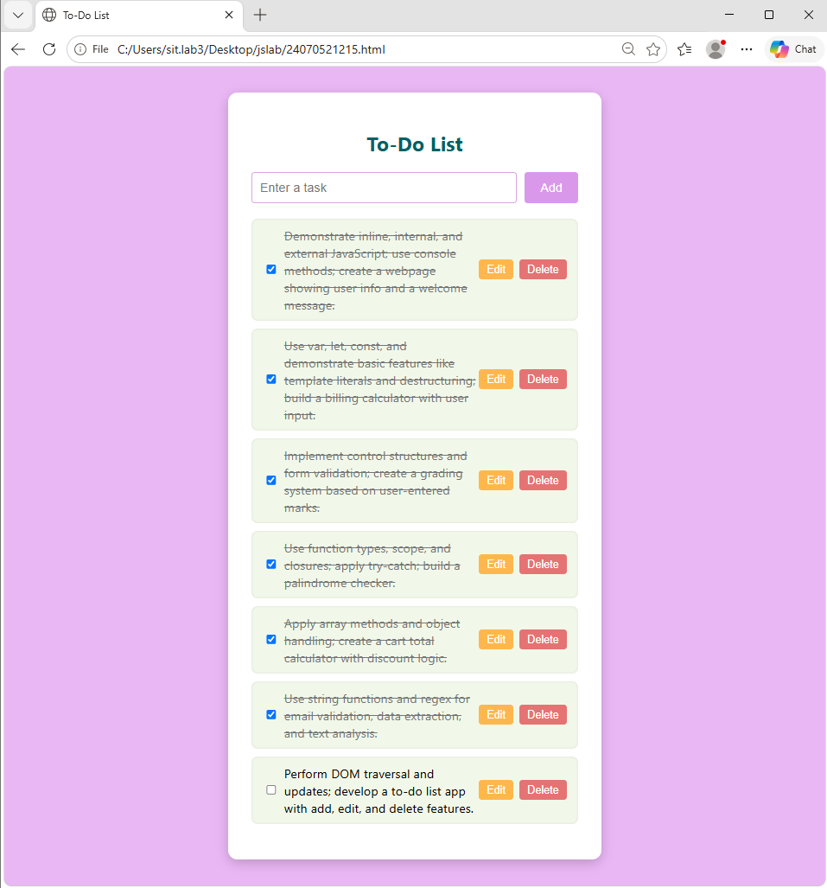
RESULT / CONCLUSION:
In conclusion, this experiment demonstrated real-time DOM tree manipulation and traversal by building a fully functional, empty-by-default To-Do List application. By leveraging node traversal methods (parentElement) and centralized event delegation on the parent container, the program smoothly handled adding new items, toggling visual completion states, replacing elements with inline edit boxes, and removing items on demand. The visual output confirmed the absolute correctness of the script, showcasing accurate tracking of the live task counter and immediate element updates.

CASE STUDY 7
TITLE:
Client-Side Form Validation and Dynamic DOM Event Handling System

AIM:
To design and implement a structured user registration form using HTML5, CSS3, and JavaScript that demonstrates programmatic DOM generation, event-driven state changes (focus, change, submit), and robust multi-tier client-side data validation.

THEORY:
Dynamic DOM Generation:
- Instead of hardcoding 31 day entries and 100 year entries in HTML, JavaScript loops dynamically create <option> elements using document.createElement() and mount them to <select> elements using appendChild().
- new Date().getFullYear() dynamically computes the current year, keeping the dropdown valid over time without hardcoded dates.
JavaScript Event-Driven Architecture:
- focus / blur: Detects user navigation between form controls to provide visual cues (highlighted blue borders and tinted backgrounds).
- change: Listens for value updates once a field loses focus, enabling instant mismatch checks before submission.
- submit & event.preventDefault(): Overrides default browser submit behavior, keeping the user on the same page while JavaScript validates inputs.
Validation Mechanisms:
- Empty-Field Check: Traverses required fields via forEach(), flagging empty entries with .trim() === "" and highlighting them with dynamic inline border styles.
- Pattern Matching (Regex): Validates email format using the standard pattern:
$$/^{\left[\backslash s@\right]}+@\left[\backslash s@\right]+\backslash .\left[\backslash s@\right]+\$/$$
- Equality Verification: Confirms password.value === repassword.value.
- Boolean State Evaluation: Checks checkbox.checked to enforce Terms & Conditions agreement.

PROJECT DESCRIPTION:
The application is a standalone front-end registration interface with integrated client-side validation logic:
- Auto-Populating Date of Birth Selectors:
  - On script execution, self-invoking loops build the options for Day (1–31) and Year (current year down to 100 years prior).
- Real-Time Interactive Feedback:
  - CSS :focus pseudo-classes and JS event listeners enhance the active input field visually.
  - A change listener on the "Re-password" field immediately checks whether it matches the initial password and shows/hides an error message.
- Comprehensive Form Submission Pipeline:
  - When the "Sign up" button is clicked, an event handler halts page reload (event.preventDefault()) and runs four verification checks sequentially:
    - Highlights any empty mandatory field with a red border and triggers an alert.
    - Runs a Regular Expression test on the email format.
    - Checks password equality.
    - Verifies the Terms & Conditions checkbox.
  - If all checks pass, a success alert is triggered, form.reset() clears all fields, and default border styles are restored.

CODE:
<!DOCTYPE html>
<html lang="en">
<head>
<meta charset="UTF-8">
<meta name="viewport" content="width=device-width, initial-scale=1.0">
<title>Event Handling Case Study</title>
<style>
body {
font-family: Arial, sans-serif;
background-color: #f5f5f5;
padding: 20px;
}
.form-container {
background-color: white;
border: 1px solid #ccc;
width: 480px;
padding: 20px;
margin: 0 auto;
box-shadow: 2px 2px 8px rgba(0,0,0,0.1);
}
.mandatory-note {
color: red;
font-size: 0.9rem;
font-style: italic;
margin-bottom: 15px;
}
.form-group {
display: flex;
align-items: center;
margin-bottom: 12px;
}
.form-group label {
width: 120px;
font-size: 0.95rem;
}
.form-group input[type="text"],
.form-group input[type="password"] {
width: 220px;
padding: 4px 6px;
border: 1px solid #767676;
outline: none;
}
/* Highlight input on focus event */
.form-group input:focus, .form-group select:focus {
border: 1.5px solid #0056b3;
background-color: #f7faff;
}
.dob-selects {
display: flex;
gap: 5px;
}
.dob-selects select {
padding: 3px;
}
.required-star {
color: red;
margin-left: 5px;
}
.terms-group {
margin-left: 120px;
margin-top: 15px;
margin-bottom: 15px;
display: flex;
align-items: center;
font-size: 0.95rem;
}
.terms-group input {
margin-right: 8px;
}
.btn-group {
margin-left: 120px;
}
input[type="submit"] {
padding: 4px 12px;
cursor: pointer;
font-size: 0.95rem;
}
.error-message {
color: red;
font-size: 0.85rem;
margin-left: 120px;
margin-top: -10px;
margin-bottom: 10px;
display: none;
}
</style>
</head>
<body>

<div class="form-container">
<div class="mandatory-note">*Mandatory to fill</div>

<form id="registrationForm" novalidate>
<!-- Firstname -->
<div class="form-group">
<label for="firstname">Firstname:</label>
<input type="text" id="firstname">
<span class="required-star">*</span>
</div>

<!-- Lastname -->
<div class="form-group">
<label for="lastname">Lastname:</label>
<input type="text" id="lastname">
<span class="required-star">*</span>
</div>

<!-- Birthday -->
<div class="form-group">
<label>Birthday:</label>
<div class="dob-selects">
<select id="dobDay">
<option value="">Day</option>
<!-- Dynamic options generated via JS -->
</select>
<select id="dobMonth">
<option value="">Month</option>
<option value="1">January</option>
<option value="2">February</option>
<option value="3">March</option>
<option value="4">April</option>
<option value="5">May</option>
<option value="6">June</option>
<option value="7">July</option>
<option value="8">August</option>
<option value="9">September</option>
<option value="10">October</option>
<option value="11">November</option>
<option value="12">December</option>
</select>
<select id="dobYear">
<option value="">Year</option>
<!-- Dynamic options generated via JS -->
</select>
</div>
<span class="required-star">*</span>
</div>

<!-- Username -->
<div class="form-group">
<label for="username">Username:</label>
<input type="text" id="username">
<span class="required-star">*</span>
</div>

<!-- E-mail -->
<div class="form-group">
<label for="email">E-mail:</label>
<input type="text" id="email">
<span class="required-star">*</span>
</div>
<div class="error-message" id="emailError">Please enter a valid email address.</div>

<!-- Website -->
<div class="form-group">
<label for="website">Website:</label>
<input type="text" id="website">
<span class="required-star">*</span>
</div>

<!-- Password -->
<div class="form-group">
<label for="password">Password:</label>
<input type="password" id="password">
<span class="required-star">*</span>
</div>

<!-- Re-password -->
<div class="form-group">
<label for="repassword">Re-password:</label>
<input type="password" id="repassword">
<span class="required-star">*</span>
</div>
<div class="error-message" id="passwordError">Passwords do not match!</div>

<!-- Terms Checkbox -->
<div class="terms-group">
<input type="checkbox" id="terms">
<label for="terms">I agree to the terms & conditions.</label>
</div>

<!-- Submit Button -->
<div class="btn-group">
<input type="submit" value="Sign up">
</div>
</form>
</div>

<script>
// --- 1. Populate Dropdowns (DOM Manipulation) ---
const daySelect = document.getElementById('dobDay');
const yearSelect = document.getElementById('dobYear');

for (let i = 1; i <= 31; i++) {
let opt = document.createElement('option');
opt.value = i;
opt.innerHTML = i;
daySelect.appendChild(opt);
}

const currentYear = new Date().getFullYear();
for (let i = currentYear; i >= currentYear - 100; i--) {
let opt = document.createElement('option');
opt.value = i;
opt.innerHTML = i;
yearSelect.appendChild(opt);
}

// --- 2. Form Event Listeners & Validation Logic ---
const form = document.getElementById('registrationForm');
const emailInput = document.getElementById('email');
const passwordInput = document.getElementById('password');
const repasswordInput = document.getElementById('repassword');

const emailError = document.getElementById('emailError');
const passwordError = document.getElementById('passwordError');

// Event: 'focus' and 'blur' on all input elements to show handling state changes
const allInputs = form.querySelectorAll('input[type="text"], input[type="password"], select');
allInputs.forEach(input => {
input.addEventListener('focus', function() {
// Background properties modified inside the CSS block matching focus selectors
});
});

// Event: 'change' event tracking real-time validation for password matching
repasswordInput.addEventListener('change', function() {
if (passwordInput.value !== repasswordInput.value) {
passwordError.style.display = 'block';
} else {
passwordError.style.display = 'none';
}
});

// Event: 'submit' event logic
form.addEventListener('submit', function(event) {
event.preventDefault(); // Stop form submission for verification

let hasError = false;

// a) Empty Fields Validation check
const mandatoryFields = [
document.getElementById('firstname'),
document.getElementById('lastname'),
document.getElementById('username'),
emailInput,
document.getElementById('website'),
passwordInput,
repasswordInput,
daySelect,
document.getElementById('dobMonth'),
yearSelect
];

let emptyFound = false;
mandatoryFields.forEach(field => {
if (field.value.trim() === "") {
emptyFound = true;
field.style.border = "1.5px solid red";
} else {
field.style.border = "1px solid #767676";
}
});

if (emptyFound) {
alert("Please fill out all mandatory fields highlighted in red.");
hasError = true;
}

// b) Email Pattern Regex Validation
const emailRegex = /^[^\s@]+@[^\s@]+\.[^\s@]+$/;
if (emailInput.value.trim() !== "" && !emailRegex.test(emailInput.value)) {
emailError.style.display = 'block';
hasError = true;
} else {
emailError.style.display = 'none';
}

// c) Password Mismatch Verification check
if (passwordInput.value !== repasswordInput.value) {
passwordError.style.display = 'block';
hasError = true;
} else {
passwordError.style.display = 'none';
}

// d) Terms Agreement Validation Check
const termsCheckbox = document.getElementById('terms');
if (!termsCheckbox.checked) {
alert("You must agree to the terms and conditions to sign up.");
hasError = true;
}

// Success Execution Pipeline Trigger
if (!hasError) {
alert("Form submitted successfully!");
form.reset();
// Reset styling frames
mandatoryFields.forEach(field => field.style.border = "1px solid #767676");
}
});
</script>
</body>
</html>

OUTPUT:
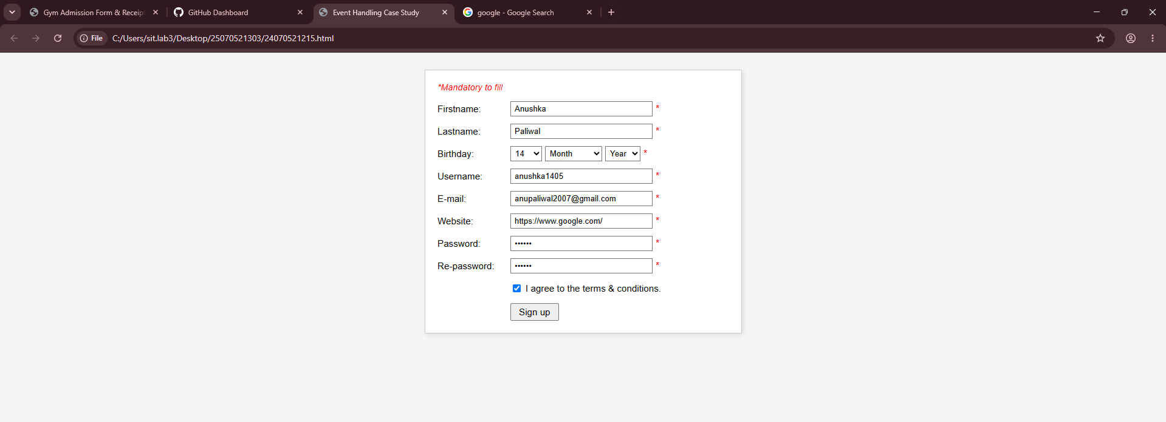

RESULT / CONCLUSION:
Operational Status: The registration interface enforces all constraints completely on the client side, eliminating unnecessary server requests for invalid data.
Key Takeaway: Demonstrates essential real-world web concepts: programmatic DOM manipulation, user experience enhancement via dynamic styling, and multi-step form verification using standard JavaScript events.

EXPERIMENT 8
AIM:
Access and validate form fields using JavaScript events; design a Gym Admission Form with live input validation and user-friendly error messages.

SOFTWARE REQUIRED:
- Any text/code editor (e.g., VS Code)
- Web browser (e.g., Chrome, Edge, Firefox) to render the HTML page
- Basic knowledge of HTML5 and modern JavaScript (ES6+)

THEORY:
HTML Forms:
HTML forms are used to collect information from users through input fields such as name, email, phone number, age, gender, and membership type. Forms provide an interactive way for users to enter and submit data.
Accessing Form Fields:
JavaScript can access form elements using methods such as getElementById(), querySelector(), and the value property. This allows the program to read and process the information entered by the user.
JavaScript Events:
Events are actions that occur on a webpage, such as input, change, focus, blur, and submit. JavaScript event handlers are used to perform specific actions when these events occur.
Form Validation:
Form validation checks whether the data entered by the user is correct and complete. It helps prevent invalid or incomplete information from being submitted.
Live Input Validation:
Live validation checks user input while the user is typing or interacting with the form. For example, it can immediately verify whether the name contains valid characters, the email format is correct, or the phone number contains the required number of digits.
Error Messages:
Error messages are displayed when invalid data is entered. They guide the user in correcting the input before submitting the form.

EXPERIMENT CONTEXT:
This experiment focuses on creating a Gym Admission Form using HTML, CSS, and JavaScript. The application collects member details such as name, age, email, phone number, gender, and membership plan. JavaScript events are used to access form fields and perform live validation, ensuring that valid information is entered before the form is submitted.

OUTPUT:
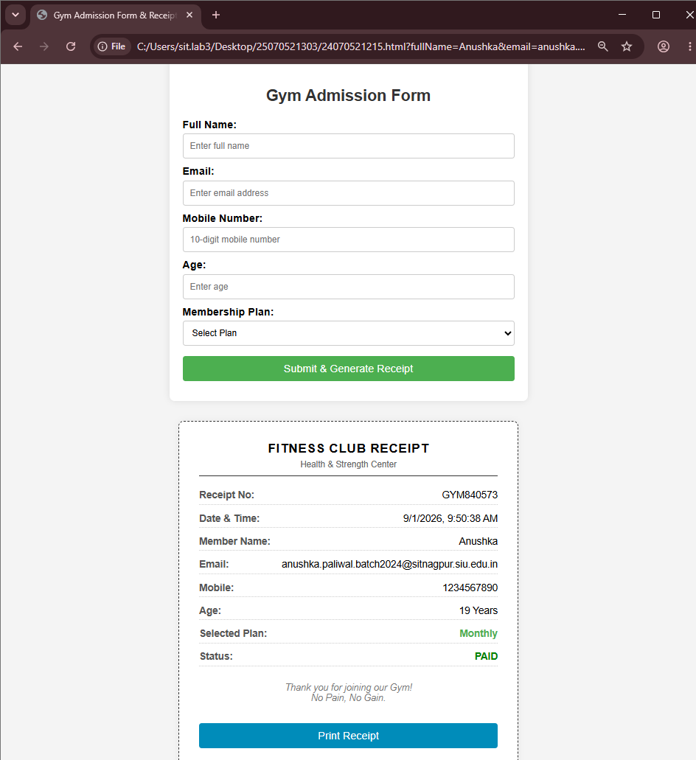
RESULT / CONCLUSION:
The experiment was successfully executed. It demonstrates the use of JavaScript arrays, array methods, object handling, and discount logic for creating a functional shopping cart application.

CASE STUDY 8
TITLE:
Multi-Step Career Portal & Interactive Application Form with Dynamic Theme Toggle

AIM:
To design and build a modern, responsive, multi-step job application portal using semantic HTML5, CSS3 variables, and vanilla JavaScript that demonstrates progressive wizard-based navigation, state management across multiple steps, dynamic tag generation, file validation, and client-side theme switching.

THEORY:
Multi-Step Form Wizard Architecture:
- Divides complex user input workflows into smaller, sequential steps (data-form="1" to data-form="4").
- Reduces user drop-off and visual clutter by mounting step indicators and a synchronized progress bar ($Step×25\%$).
- Preserves form state locally within the DOM without refreshing or submitting data prematurely.
Dynamic Tag/Chip Creation:
- Uses keyboard event listeners (keydown on Enter) to capture and parse text inputs into interactive badges.
- Employs array filtering and closure-based event handlers (span.onclick) to remove tags dynamically from both UI and memory.
File Metadata & Constraints Evaluation:
- Directly interrogates the HTML5 File API (file.size) to compute byte size into megabytes.
- Rejects uploads exceeding the $10\text{ MB}$ limit on the client side, avoiding unnecessary server bandwidth consumption.
Theme Switching via CSS Custom Properties:
- Leverages :root CSS custom properties (--bg, --card, --text, --primary) toggled via a single class (body.dark) to achieve theme persistence and layout recalibration with minimal overhead.

PROJECT DESCRIPTION:
The application is structured into four distinct workflow steps housed in a single card UI:
- Step 1: Personal Details:
  - Collects basic applicant data (firstName, lastName, email, phone, location).
  - Validates mandatory inputs using HTML5 validation (checkValidity()) and highlights invalid fields with red borders.
- Step 2: Role & Experience Selection:
  - Provides card-based selection patterns instead of default select elements.
  - Uses clickable radio-like cards for designations (Product Designer, Software Engineer, etc.) and experience buckets (0–1 to 9+ years) styled with stateful .selected CSS rules.
- Step 3: Skills & Document Upload:
  - Features a dynamic tag input where users add skills by pressing "Enter", complete with delete buttons (×).
  - File upload wrapper with real-time feedback displaying the uploaded file name and rejecting files over 10 MB.
  - Requires a motivation statement and earliest start date.
- Step 4: Review & Legal Verification:
  - Summarizes all captured data into a unified, read-only summary list prior to final commitment.
  - Enforces legal consent via a mandatory checkbox before showing an animated success state.
- Global Utility:
  - A dark/light theme switch in the header that transitions the color scheme across all containers.
CODE:
<!DOCTYPE html>
<html lang="en">
<head>
<meta charset="UTF-8">
<meta name="viewport" content="width=device-width, initial-scale=1.0">

<title>Northstar | Career Application</title>

<style>
@import url('https://fonts.googleapis.com/css2?family=DM+Sans:wght@400;500;600;700&family=Space+Grotesk:wght@500;600;700&display=swap');

*{
box-sizing:border-box;
margin:0;
padding:0;
}

:root{
--bg:#f5f7fb;
--card:#ffffff;
--text:#172033;
--muted:#697386;
--primary:#635bff;
--primary-dark:#4b44d9;
--soft:#eeecff;
--border:#e1e5ee;
--danger:#e05252;
--success:#20966b;
}

body{
font-family:'DM Sans',sans-serif;
background:var(--bg);
color:var(--text);
min-height:100vh;
transition:.3s;
}

body.dark{
--bg:#11131a;
--card:#1b1e27;
--text:#f5f7ff;
--muted:#9da5b8;
--border:#303542;
--soft:#29254c;
}

/* ================= HEADER ================= */

header{
width:100%;
padding:20px 6%;
display:flex;
justify-content:space-between;
align-items:center;
border-bottom:1px solid var(--border);
background:var(--card);
}

.logo{
display:flex;
align-items:center;
gap:10px;
font-family:'Space Grotesk';
font-weight:700;
font-size:20px;
}

.logo-icon{
width:36px;
height:36px;
display:grid;
place-items:center;
border-radius:11px;
background:var(--primary);
color:white;
}

.header-right{
display:flex;
align-items:center;
gap:20px;
color:var(--muted);
font-size:13px;
}

.theme-btn{
border:1px solid var(--border);
background:var(--card);
color:var(--text);
width:40px;
height:40px;
border-radius:50%;
cursor:pointer;
font-size:18px;
}

/* ================= MAIN ================= */

.container{
max-width:1150px;
margin:45px auto;
padding:0 25px;
}

.hero{
margin-bottom:35px;
}

.badge{
display:inline-block;
padding:7px 13px;
border-radius:20px;
background:var(--soft);
color:var(--primary);
font-size:12px;
font-weight:700;
margin-bottom:15px;
}

.hero h1{
font-family:'Space Grotesk';
font-size:clamp(35px,5vw,58px);
line-height:1;
margin-bottom:15px;
}

.hero p{
color:var(--muted);
max-width:650px;
line-height:1.6;
}

/* ================= PROGRESS ================= */

.progress-box{
margin-bottom:25px;
}

.progress-info{
display:flex;
justify-content:space-between;
font-size:13px;
color:var(--muted);
margin-bottom:8px;
}

.progress{
height:7px;
background:var(--border);
border-radius:20px;
overflow:hidden;
}

.progress-bar{
width:25%;
height:100%;
background:var(--primary);
transition:.4s;
}

/* ================= STEPS ================= */

.steps{
display:flex;
justify-content:space-between;
margin-bottom:25px;
}

.step{
display:flex;
align-items:center;
gap:8px;
color:var(--muted);
font-size:13px;
}

.step-number{
width:28px;
height:28px;
border:1px solid var(--border);
border-radius:50%;
display:grid;
place-items:center;
background:var(--card);
}

.step.active{
color:var(--primary);
font-weight:700;
}

.step.active .step-number{
background:var(--primary);
color:white;
border-color:var(--primary);
}

/* ================= FORM CARD ================= */

.form-card{
background:var(--card);
border:1px solid var(--border);
border-radius:22px;
padding:38px;
box-shadow:0 15px 50px rgba(0,0,0,.05);
}

.form-step{
display:none;
}

.form-step.active{
display:block;
animation:slide .35s ease;
}

@keyframes slide{
from{
opacity:0;
transform:translateX(15px);
}
to{
opacity:1;
transform:translateX(0);
}
}

.section-title{
font-family:'Space Grotesk';
font-size:25px;
margin-bottom:7px;
}

.section-description{
color:var(--muted);
font-size:14px;
margin-bottom:28px;
}

/* ================= INPUTS ================= */

.grid{
display:grid;
grid-template-columns:1fr 1fr;
gap:20px;
}

.full{
grid-column:1/-1;
}

.field{
display:flex;
flex-direction:column;
gap:8px;
}

label{
font-size:13px;
font-weight:700;
}

input,
textarea{
width:100%;
padding:14px;
border:1px solid var(--border);
border-radius:10px;
background:transparent;
color:var(--text);
font:inherit;
outline:none;
transition:.2s;
}

textarea{
min-height:120px;
resize:vertical;
}

input:focus,
textarea:focus{
border-color:var(--primary);
box-shadow:0 0 0 3px rgba(99,91,255,.12);
}

input.valid{
border-color:var(--success);
}

input.invalid{
border-color:var(--danger);
}

.error{
color:var(--danger);
font-size:11px;
display:none;
}

.field.invalid .error{
display:block;
}

/* ================= ROLE CARDS ================= */

.role-grid{
display:grid;
grid-template-columns:repeat(2,1fr);
gap:15px;
}

.role-card{
padding:20px;
border:1px solid var(--border);
border-radius:14px;
cursor:pointer;
transition:.2s;
}

.role-card:hover{
transform:translateY(-3px);
border-color:var(--primary);
}

.role-card.selected{
background:var(--soft);
border-color:var(--primary);
}

.role-icon{
font-size:25px;
margin-bottom:12px;
}

.role-card h3{
font-size:15px;
margin-bottom:5px;
}

.role-card p{
color:var(--muted);
font-size:12px;
}

input[type="radio"]{
display:none;
}

/* ================= EXPERIENCE ================= */

.exp-grid{
display:grid;
grid-template-columns:repeat(4,1fr);
gap:12px;
}

.exp-card{
padding:18px 10px;
border:1px solid var(--border);
border-radius:12px;
text-align:center;
cursor:pointer;
font-size:13px;
}

.exp-card.selected{
background:var(--soft);
border-color:var(--primary);
color:var(--primary);
font-weight:700;
}

/* ================= SKILLS ================= */

.skill-input{
display:flex;
flex-wrap:wrap;
gap:8px;
padding:10px;
border:1px solid var(--border);
border-radius:10px;
}

.skill-input input{
border:0;
box-shadow:none;
flex:1;
min-width:130px;
padding:7px;
}

.skill{
background:var(--soft);
color:var(--primary);
padding:7px 10px;
border-radius:20px;
font-size:12px;
display:flex;
gap:7px;
align-items:center;
}

.skill span{
cursor:pointer;
font-weight:bold;
}

/* ================= UPLOAD ================= */

.upload{
border:2px dashed var(--border);
padding:35px;
border-radius:14px;
text-align:center;
cursor:pointer;
transition:.2s;
}

.upload:hover{
border-color:var(--primary);
background:var(--soft);
}

.upload-icon{
font-size:35px;
margin-bottom:10px;
}

.upload p{
color:var(--muted);
font-size:13px;
}

#resume{
display:none;
}

/* ================= WORK CARDS ================= */

.preference-grid{
display:grid;
grid-template-columns:repeat(3,1fr);
gap:15px;
}

.preference{
border:1px solid var(--border);
padding:20px;
border-radius:14px;
text-align:center;
cursor:pointer;
}

.preference.selected{
border-color:var(--primary);
background:var(--soft);
}

.preference .emoji{
font-size:28px;
margin-bottom:10px;
}

/* ================= REVIEW ================= */

.review{
display:grid;
gap:12px;
}

.review-item{
display:flex;
justify-content:space-between;
gap:20px;
padding:14px;
background:var(--bg);
border-radius:10px;
font-size:13px;
}

.review-item span:first-child{
color:var(--muted);
}

/* ================= BUTTONS ================= */

.buttons{
display:flex;
justify-content:space-between;
margin-top:35px;
padding-top:25px;
border-top:1px solid var(--border);
}

button{
font-family:inherit;
}

.next,
.submit{
background:var(--primary);
color:white;
border:0;
padding:13px 23px;
border-radius:9px;
font-weight:700;
cursor:pointer;
}

.next:hover,
.submit:hover{
background:var(--primary-dark);
}

.back{
background:transparent;
border:1px solid var(--border);
color:var(--text);
padding:13px 23px;
border-radius:9px;
cursor:pointer;
}

/* ================= SUCCESS ================= */

.success{
display:none;
text-align:center;
padding:70px 20px;
}

.success.show{
display:block;
animation:pop .5s ease;
}

@keyframes pop{
from{
opacity:0;
transform:scale(.8);
}
to{
opacity:1;
transform:scale(1);
}
}

.success-icon{
width:80px;
height:80px;
margin:auto auto 20px;
display:grid;
place-items:center;
border-radius:50%;
background:#d9f5e9;
color:var(--success);
font-size:40px;
}

.success h2{
font-family:'Space Grotesk';
font-size:30px;
margin-bottom:10px;
}

.success p{
color:var(--muted);
}

/* ================= RESPONSIVE ================= */

@media(max-width:700px){

.container{
margin:25px auto;
}

.form-card{
padding:23px;
}

.grid,
.role-grid{
grid-template-columns:1fr;
}

.full{
grid-column:auto;
}

.exp-grid{
grid-template-columns:1fr 1fr;
}

.preference-grid{
grid-template-columns:1fr;
}

.step span{
display:none;
}

.header-right small{
display:none;
}
}
</style>
</head>

<body>

<header>

<div class="logo">
<div class="logo-icon">N</div>
NORTHSTAR
</div>

<div class="header-right">
<small>Build your next chapter.</small>
<button class="theme-btn" id="themeBtn">☾</button>
</div>

</header>

<div class="container">

<div class="hero">

<span class="badge">CAREERS 2026</span>

<h1>Let's build<br>something meaningful.</h1>

<p>
We're looking for curious people who enjoy solving difficult
problems, learning quickly and creating work that matters.
</p>

</div>

<!-- PROGRESS -->

<div class="progress-box">

<div class="progress-info">
<span id="progressText">Step 1 of 4</span>
<span id="progressPercent">25%</span>
</div>

<div class="progress">
<div class="progress-bar" id="progressBar"></div>
</div>

</div>

<!-- STEPS -->

<div class="steps">

<div class="step active" data-step="1">
<div class="step-number">1</div>
<span>About you</span>
</div>

<div class="step" data-step="2">
<div class="step-number">2</div>
<span>Your role</span>
</div>

<div class="step" data-step="3">
<div class="step-number">3</div>
<span>Your skills</span>
</div>

<div class="step" data-step="4">
<div class="step-number">4</div>
<span>Review</span>
</div>

</div>

<!-- FORM -->

<div class="form-card">

<form id="applicationForm">

<!-- STEP 1 -->

<div class="form-step active" data-form="1">

<h2 class="section-title">Tell us about yourself</h2>

<p class="section-description">
Start with some basic information so we know who we're speaking with.
</p>

<div class="grid">

<div class="field">
<label>First name *</label>
<input type="text" id="firstName" placeholder="Alex" required>
<small class="error">Please enter your first name.</small>
</div>

<div class="field">
<label>Last name *</label>
<input type="text" id="lastName" placeholder="Morgan" required>
<small class="error">Please enter your last name.</small>
</div>

<div class="field">
<label>Email address *</label>
<input type="email" id="email" placeholder="alex@example.com" required>
<small class="error">Enter a valid email address.</small>
</div>

<div class="field">
<label>Phone number</label>
<input type="tel" id="phone" placeholder="+91 98765 43210">
</div>

<div class="field full">
<label>Current city *</label>
<input type="text" id="location" placeholder="Nagpur, India" required>
<small class="error">Please enter your city.</small>
</div>

</div>

<div class="buttons">
<span></span>
<button type="button" class="next">Continue →</button>
</div>

</div>

<!-- STEP 2 -->

<div class="form-step" data-form="2">

<h2 class="section-title">Find your place</h2>

<p class="section-description">
Choose the role that feels closest to what you want to build.
</p>

<label>What role are you applying for? *</label>

<br><br>

<div class="role-grid">

<label class="role-card">
<input type="radio" name="role" value="Product Designer">
<div class="role-icon">🎨</div>
<h3>Product Designer</h3>
<p>Design experiences people love.</p>
</label>

<label class="role-card">
<input type="radio" name="role" value="Software Engineer">
<div class="role-icon">💻</div>
<h3>Software Engineer</h3>
<p>Build scalable digital products.</p>
</label>

<label class="role-card">
<input type="radio" name="role" value="Marketing">
<div class="role-icon">📈</div>
<h3>Marketing</h3>
<p>Turn ideas into growth.</p>
</label>

<label class="role-card">
<input type="radio" name="role" value="Customer Success">
<div class="role-icon">🤝</div>
<h3>Customer Success</h3>
<p>Help customers achieve more.</p>
</label>

</div>

<br><br>

<label>Years of experience *</label>

<br><br>

<div class="exp-grid">

<div class="exp-card">0–1 years</div>
<div class="exp-card">2–4 years</div>
<div class="exp-card">5–8 years</div>
<div class="exp-card">9+ years</div>

</div>

<div class="buttons">

<button type="button" class="back">← Back</button>

<button type="button" class="next">Continue →</button>

</div>

</div>

<!-- STEP 3 -->

<div class="form-step" data-form="3">

<h2 class="section-title">Show us what you bring</h2>

<p class="section-description">
Add your skills and upload your latest resume.
</p>

<div class="field">

<label>Technical / professional skills *</label>

<div class="skill-input" id="skillBox">

<input
type="text"
id="skillInput"
placeholder="Type a skill and press Enter"
>

</div>

<small class="error" id="skillError">
Add at least one skill.
</small>

</div>

<br>

<div class="field">

<label>Resume / CV *</label>

<label class="upload" for="resume">

<div class="upload-icon">📄</div>

<strong id="uploadText">
Drop your resume here
</strong>

<p>
or click to browse · PDF, DOC, DOCX · Max 10 MB
</p>

</label>

<input
type="file"
id="resume"
accept=".pdf,.doc,.docx"
>

</div>

<br>

<div class="grid">

<div class="field">

<label>Portfolio / LinkedIn</label>

<input
type="url"
id="portfolio"
placeholder="https://linkedin.com/in/..."
>

</div>

<div class="field">

<label>Earliest start date *</label>

<input
type="date"
id="startDate"
required
>

</div>

</div>

<br>

<div class="field">

<label>Why do you want to join Northstar? *</label>

<textarea
id="motivation"
placeholder="Tell us what excites you about this opportunity..."
required
></textarea>

</div>

<div class="buttons">

<button type="button" class="back">← Back</button>

<button type="button" class="next">Continue →</button>

</div>

</div>

<!-- STEP 4 -->

<div class="form-step" data-form="4">

<h2 class="section-title">Almost there.</h2>

<p class="section-description">
Review your application before sending it to our team.
</p>

<div class="review">

<div class="review-item">
<span>Name</span>
<strong id="reviewName">—</strong>
</div>

<div class="review-item">
<span>Email</span>
<strong id="reviewEmail">—</strong>
</div>

<div class="review-item">
<span>Location</span>
<strong id="reviewLocation">—</strong>
</div>

<div class="review-item">
<span>Role</span>
<strong id="reviewRole">—</strong>
</div>

<div class="review-item">
<span>Experience</span>
<strong id="reviewExperience">—</strong>
</div>

<div class="review-item">
<span>Skills</span>
<strong id="reviewSkills">—</strong>
</div>

<div class="review-item">
<span>Resume</span>
<strong id="reviewResume">—</strong>
</div>

</div>

<br><br>

<label style="display:flex;gap:10px;align-items:flex-start;font-weight:400">

<input
type="checkbox"
id="consent"
style="width:auto;margin-top:3px"
>

I confirm that the information provided is accurate and
I consent to its use for recruitment purposes.

</label>

<div class="buttons">

<button type="button" class="back">← Back</button>

<button type="submit" class="submit">
Submit application ✦
</button>

</div>

</div>

</form>

<!-- SUCCESS -->

<div class="success" id="success">

<div class="success-icon">✓</div>

<h2>Application submitted!</h2>

<p>
Thanks for sharing your story.
Our team will review your application and get back to you.
</p>

</div>

</div>

</div>

<script>

/* ================= VARIABLES ================= */

let currentStep = 1;

const totalSteps = 4;

const form = document.getElementById("applicationForm");

const steps = document.querySelectorAll(".form-step");

const stepIndicators = document.querySelectorAll(".step");

const progressBar = document.getElementById("progressBar");

const progressText = document.getElementById("progressText");

const progressPercent = document.getElementById("progressPercent");

/* ================= UPDATE STEP ================= */

function showStep(step){

currentStep = step;

steps.forEach(s => {

s.classList.remove("active");

if(Number(s.dataset.form) === step){
s.classList.add("active");
}

});

stepIndicators.forEach(s => {

s.classList.remove("active");

if(Number(s.dataset.step) <= step){
s.classList.add("active");
}

});

const percent = step * 25;

progressBar.style.width = percent + "%";

progressText.textContent = `Step ${step} of ${totalSteps}`;

progressPercent.textContent = percent + "%";

}

/* ================= VALIDATION ================= */

function validateStep(){

if(currentStep === 1){

const required = [
"firstName",
"lastName",
"email",
"location"
];

let valid = true;

required.forEach(id => {

const input = document.getElementById(id);
const field = input.parentElement;

if(!input.value.trim() || !input.checkValidity()){

field.classList.add("invalid");
valid = false;

}else{

field.classList.remove("invalid");
input.classList.add("valid");

}

});

return valid;
}

if(currentStep === 2){

const role = document.querySelector('input[name="role"]:checked');

const experience =
document.querySelector(".exp-card.selected");

if(!role){

alert("Please select a role.");

return false;
}

if(!experience){

alert("Please select your experience.");

return false;
}

return true;
}

if(currentStep === 3){

if(skills.length === 0){

document.getElementById("skillError").style.display="block";

return false;

}

document.getElementById("skillError").style.display="none";

const resume =
document.getElementById("resume");

if(!resume.files.length){

alert("Please upload your resume.");

return false;

}

const motivation =
document.getElementById("motivation");

if(!motivation.value.trim()){

alert("Please tell us why you want to join Northstar.");

return false;

}

return true;
}

return true;
}

/* ================= NEXT BUTTON ================= */

document.querySelectorAll(".next").forEach(button => {

button.addEventListener("click", () => {

if(validateStep()){

if(currentStep < totalSteps){

if(currentStep === 3){

updateReview();

}

showStep(currentStep + 1);

}

}

});

});

/* ================= BACK BUTTON ================= */

document.querySelectorAll(".back").forEach(button => {

button.addEventListener("click", () => {

if(currentStep > 1){

showStep(currentStep - 1);

}

});

});

/* ================= ROLE SELECTION ================= */

document.querySelectorAll(".role-card").forEach(card => {

card.addEventListener("click", () => {

document.querySelectorAll(".role-card")
.forEach(c => c.classList.remove("selected"));

card.classList.add("selected");

});

});

/* ================= EXPERIENCE ================= */

document.querySelectorAll(".exp-card").forEach(card => {

card.addEventListener("click", () => {

document.querySelectorAll(".exp-card")
.forEach(c => c.classList.remove("selected"));

card.classList.add("selected");

});

});

/* ================= SKILLS ================= */

const skillInput =
document.getElementById("skillInput");

const skillBox =
document.getElementById("skillBox");

let skills = [];

skillInput.addEventListener("keydown", function(event){

if(event.key === "Enter"){

event.preventDefault();

const value = skillInput.value.trim();

if(value && !skills.includes(value)){

skills.push(value);

createSkill(value);

}

skillInput.value = "";

}

});

function createSkill(value){

const skill = document.createElement("div");

skill.className = "skill";

skill.innerHTML = `
${value}
<span>×</span>
`;

skill.querySelector("span").onclick = () => {

skills = skills.filter(s => s !== value);

skill.remove();

};

skillBox.insertBefore(skill, skillInput);

}

/* ================= FILE UPLOAD ================= */

const resume =
document.getElementById("resume");

const uploadText =
document.getElementById("uploadText");

resume.addEventListener("change", () => {

if(resume.files.length){

const file = resume.files[0];

const sizeMB = file.size / (1024 * 1024);

if(sizeMB > 10){

alert("File size must be below 10 MB.");

resume.value = "";

uploadText.textContent =
"Drop your resume here";

return;

}

uploadText.textContent =
"✓ " + file.name;

}

});

/* ================= REVIEW ================= */

function updateReview(){

document.getElementById("reviewName").textContent =
document.getElementById("firstName").value +
" " +
document.getElementById("lastName").value;

document.getElementById("reviewEmail").textContent =
document.getElementById("email").value;

document.getElementById("reviewLocation").textContent =
document.getElementById("location").value;

const role =
document.querySelector('input[name="role"]:checked');

document.getElementById("reviewRole").textContent =
role ? role.value : "—";

const experience =
document.querySelector(".exp-card.selected");

document.getElementById("reviewExperience").textContent =
experience ? experience.textContent : "—";

document.getElementById("reviewSkills").textContent =
skills.length ? skills.join(", ") : "—";

const file =
document.getElementById("resume").files[0];

document.getElementById("reviewResume").textContent =
file ? file.name : "—";

}

/* ================= SUBMIT ================= */

form.addEventListener("submit", function(event){

event.preventDefault();

if(!document.getElementById("consent").checked){

alert("Please accept the consent statement.");

return;

}

form.style.display = "none";

document.querySelector(".steps").style.display = "none";

document.querySelector(".progress-box").style.display = "none";

document.getElementById("success").classList.add("show");

});

/* ================= DARK MODE ================= */

document.getElementById("themeBtn")
.addEventListener("click", () => {

document.body.classList.toggle("dark");

const button =
document.getElementById("themeBtn");

button.textContent =
document.body.classList.contains("dark")
? "☀"
: "☾";

});

</script>

</body>
</html>
OUTPUT:
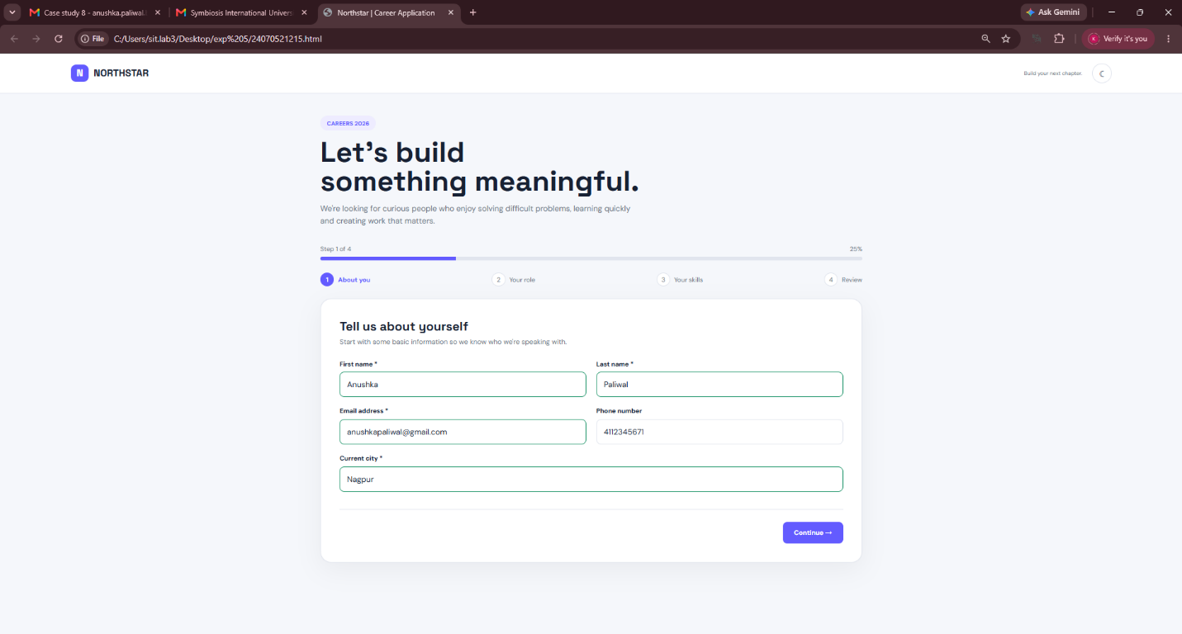
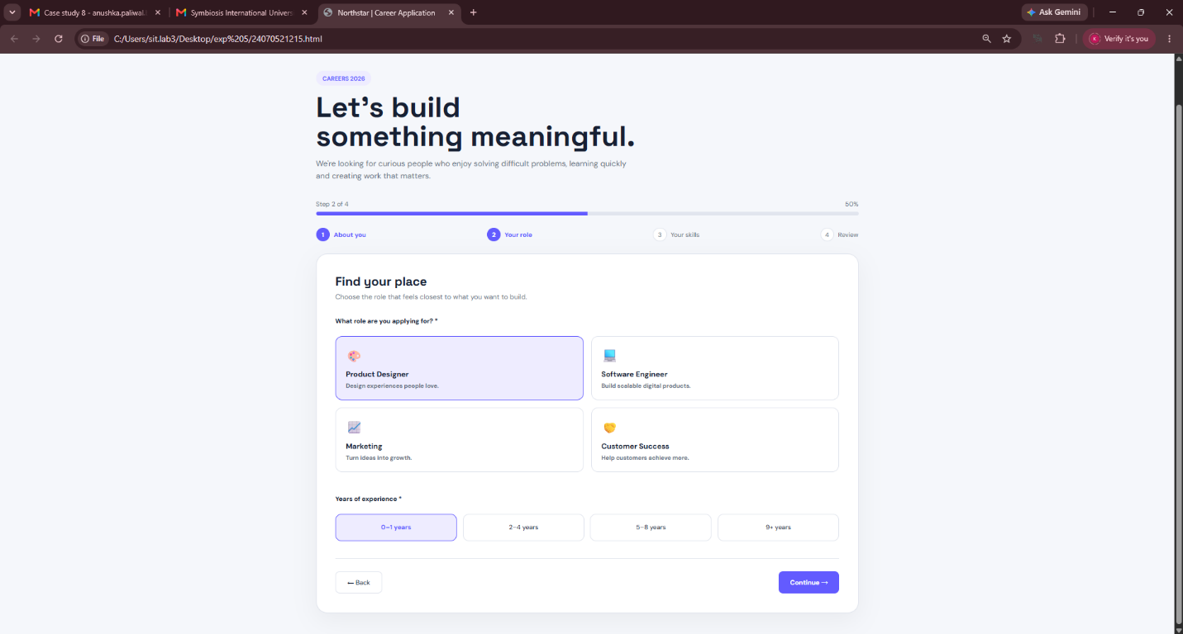
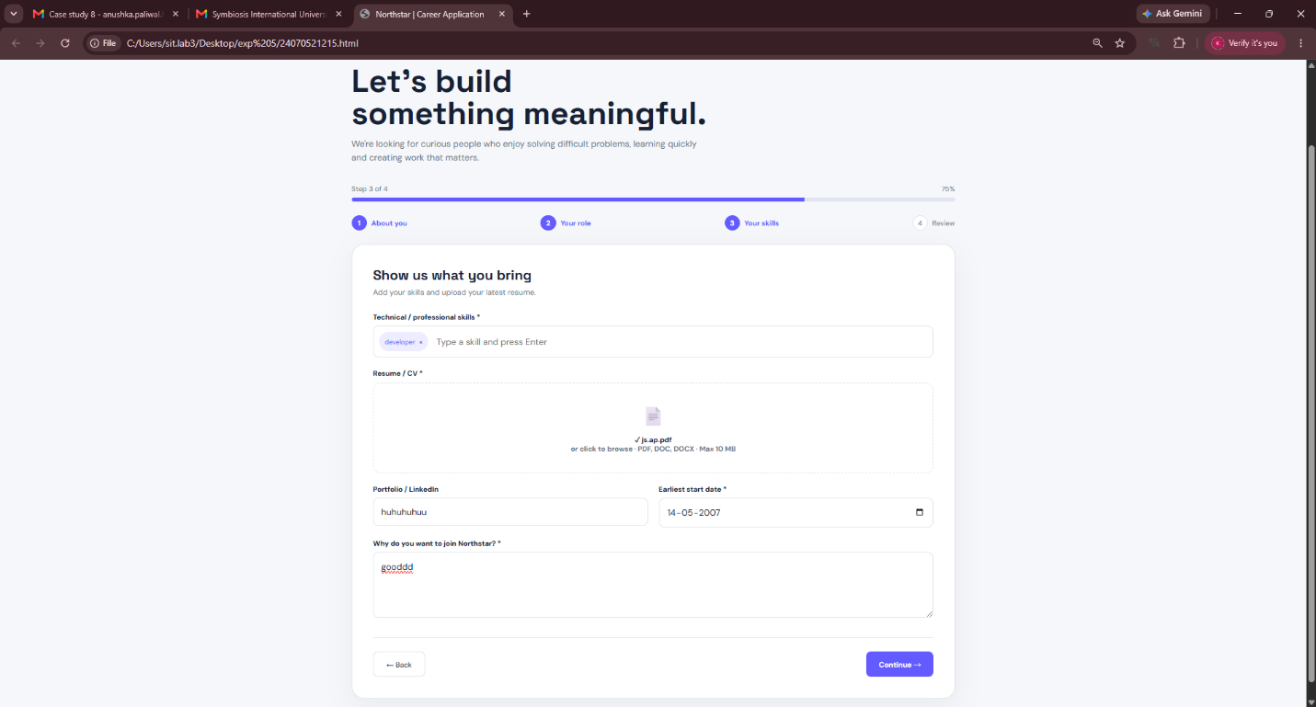
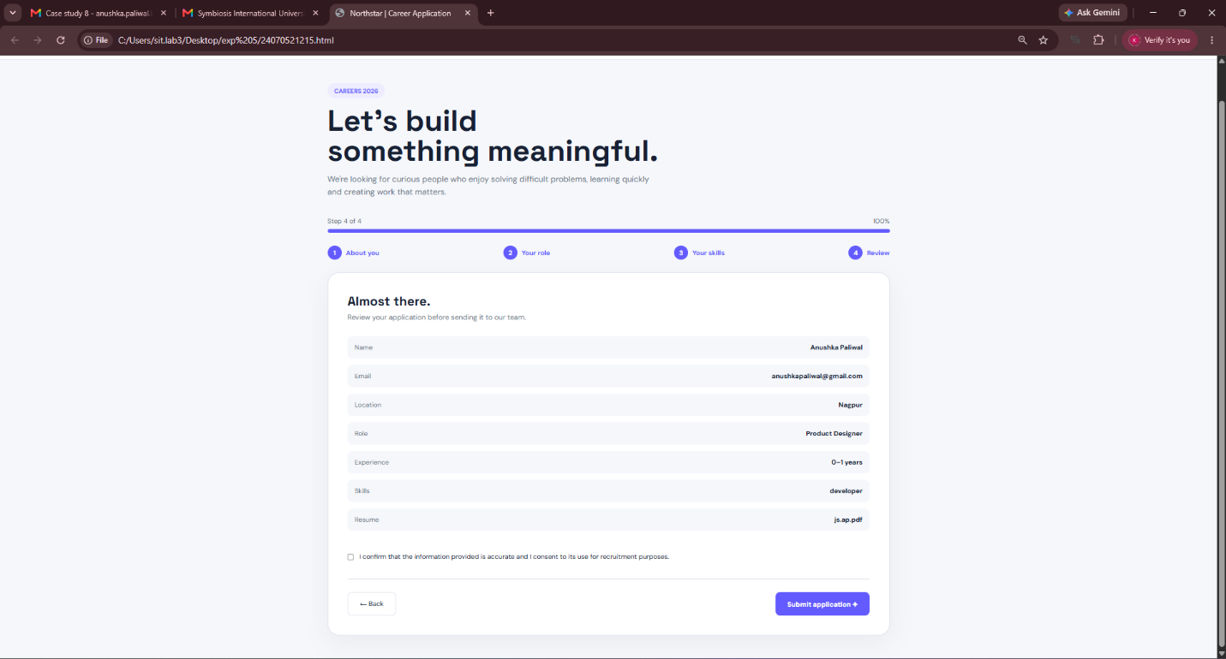
RESULT/CONCLUSION:
Operational Status: The multi-step wizard navigates through all four stages without state corruption, blocks progression on failed validation, and dynamically compiles review data before triggering a clean completion animation. Key Takeaway: Demonstrates real-world production UI patterns: modern CSS token design, component-level card selection, progressive validation loops, and responsive layout scaling.
EXPERIMENT 9
AIM:
Implement Web Storage API (localStorage and sessionStorage) using JavaScript to store and persist user preferences such as theme settings (Dark/Light mode) and session-specific states.

SOFTWARE REQUIRED:
- Any text/code editor (e.g., VS Code)
- Web browser (e.g., Chrome, Edge, Firefox) to render the HTML page
- Basic knowledge of HTML5, CSS3, and modern JavaScript (ES6+)
THEORY:
Web Storage API:
Provides mechanisms by which browsers can securely store key-value pairs in a much cleaner way than using cookies. It consists of two primary mechanisms: localStorage and sessionStorage.
localStorage:
Stores data with no expiration date. The data stored in localStorage persists even when the browser window or tab is closed and reopened. It is ideal for saving persistent user preferences such as selected UI themes, language settings, or layout choices.
sessionStorage:
Stores data only for the duration of the current page session. A page session lasts as long as the browser or tab remains open. Once the tab is closed, the data stored in sessionStorage is cleared. It is useful for temporary form data or session counters.
Storage Methods:
- setItem(key, value): Adds or updates a key with a corresponding string value.
- getItem(key): Retrieves the value associated with the specified key.
- removeItem(key): Deletes the specified key and its associated value.
- clear(): Clears all key-value pairs stored in the storage object.

User Preferences (Theme Settings):
Theme preference allows users to switch between Light Mode and Dark Mode. By reading stored values upon page load, the application dynamically applies CSS classes to ensure the user’s chosen theme remains intact across page refreshes.

EXPERIMENT CONTEXT:
This experiment demonstrates how to build a responsive settings panel that allows users to toggle between Light and Dark themes, choose an accent color, and manage session notes. localStorage is used to retain persistent theme configurations across browser restarts, while sessionStorage manages temporary session data.

OUTPUT:
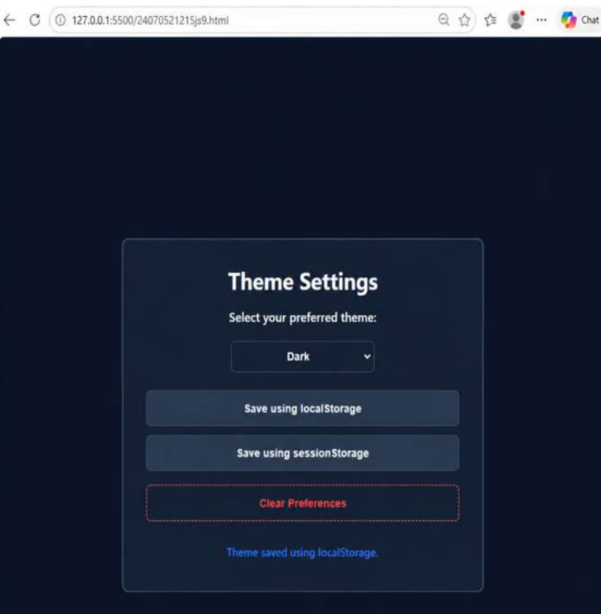
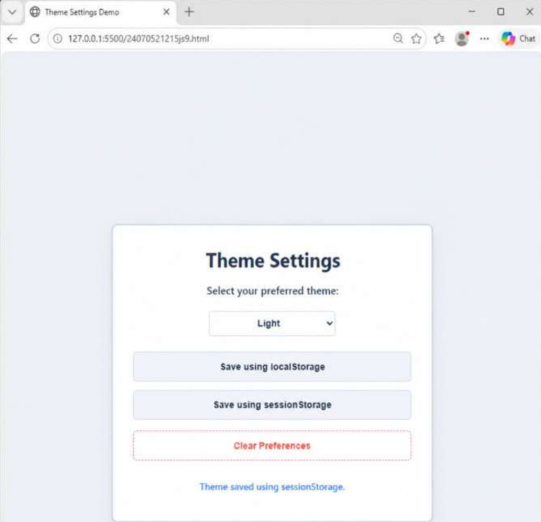

RESULT / CONCLUSION:
The experiment was successfully executed. It demonstrates the implementation of the Web Storage API (localStorage and sessionStorage) in JavaScript to store, retrieve, and remove key-value pairs to maintain persistent theme preferences and manage tab-specific session states.

CASE STUDY 9
TITLE:
Implementation of Universal High-Contrast (Black & White / Dark Mode) Theme Across Web Development Lab Experiments
AIM:
To design, standardize, and implement an accessible Black & White / Dark Mode theme across all prior laboratory experiments using CSS specificity hierarchy (Inline, Internal, and External CSS), CSS class toggling, and DOM manipulation to ensure uniform readability and visual contrast.

THEORY:
CSS Specificity and Cascade Hierarchy:
- Styles cascade according to precedence:
$$\text{Inline Styles}>\text{Internal Styles (}<\text{style}>\text{)}>\text{External Styles (}<\text{link}>\text{)}$$
- When applying a global dark or high-contrast theme via class toggling (body.dark-mode), inline styles (e.g., hardcoded hex values) block class-based CSS overrides unless:
  - The !important rule is declared in the stylesheet to elevate specificity.
  - Dynamic DOM manipulation (element.style.backgroundColor) programmatically overwrites inline style attributes during state transitions.
Class Toggling & State Handling (classList.toggle):
- Adding a single class (.dark-mode) to document.body allows nested selector rules (e.g., body.dark-mode .box, body.dark-mode input) to simultaneously restyle child components across all modules without modifying individual markup structures.
Monochromatic Contrast Engineering:
- Replacing multi-hue backgrounds with achromatic/monochromatic shades (#1a202c, #2d3748, #ffffff, #000000) optimizes WCAG contrast compliance, reduces eye strain, and provides a unified UI baseline for multiple experiments.

PROJECT DESCRIPTION:
This project develops and applies a universal theme switch mechanism to standardize the visual presentation of lab assignments:
- Architecture & Scope:
  - Demonstrates how the three CSS methods (Inline, Internal, and External) behave when challenged with dynamic runtime theme re-rendering.
  - Serves as the master styling template adaptable to all 8 core laboratory experiments (e.g., Array Manipulator, String & Vowel Analyzer, Event Handling Forms, Career Portal).
- Styling Strategy:
  - Base / Light Mode: Employs vibrant background hues (#667eea), white surface cards, soft box shadows, and distinct accent borders.
  - Dark / Monochromatic Mode: Leverages targeted class-based inheritance (body.dark-mode) to reassign containers to deep slate/charcoal hues, text elements to high-contrast off-whites (#e2e8f0), and intensifies drop shadows for spatial layering.
- Runtime DOM Interception (toggleMode()):
  - Toggles the .dark-mode class on the root <body>.
  - Directly targets elements carrying hardcoded inline styles (inlineBox, internalBox) via getElementById to ensure inline declarations do not break dark mode styling.
  - Updates interactive controls, providing a responsive toggle button

CODE:
EXPERIMENT 1:-
<!DOCTYPE html>
<html lang="en">
<head>
<meta charset="UTF-8">
<meta name="viewport" content="width=device-width, initial-scale=1.0">
<title>CSS - Three Methods Demo</title>
<!-- EXTERNAL CSS -->
<link rel="stylesheet" href="styles.css">

<!-- INTERNAL CSS -->
<style>
/* Remove default margins and padding from all elements */
* {
margin: 0;
padding: 0;
box-sizing: border-box;
}

/* Style for the entire page background and layout */
body {
font-family: 'Arial', sans-serif;
/* Set background color to light blue */
background-color: #667eea;
/* Set minimum height to full viewport height */
min-height: 100vh;
/* Add space inside the body (padding) */
padding: 30px;
transition: background-color 0.3s ease, color 0.3s ease;
}

/* --- DARK MODE STYLES --- */
body.dark-mode {
background-color: #1a202c; /* Dark background */
}

body.dark-mode .box {
background-color: #2d3748 !important; /* Darker boxes */
color: #ffffff;
box-shadow: 0 8px 20px rgba(0,0,0,0.5);
}

body.dark-mode .box p {
color: #e2e8f0 !important; /* Light text for readability */
}

/* Toggle Button Style */
.toggle-btn {
display: block;
margin: 0 auto 20px auto;
padding: 10px 20px;
font-size: 1em;
font-weight: bold;
cursor: pointer;
border: none;
border-radius: 20px;
background-color: #ffffff;
color: #333333;
box-shadow: 0 4px 10px rgba(0,0,0,0.1);
transition: all 0.3s ease;
}

body.dark-mode .toggle-btn {
background-color: #4a5568;
color: #ffffff;
}
/* ------------------------ */

/* Style for the container that holds all boxes */
.container {
/* Maximum width of 800px to keep content centered */
max-width: 800px;
/* Center the container with margin */
margin: 0 auto;
}

/* Style for the main heading */
h1 {
/* Center align the text */
text-align: center;
/* Change text color to white */
color: white;
/* Add space below the heading */
margin-bottom: 40px;
/* Make text larger */
font-size: 2.5em;
}

/* Style for each colored box */
.box {
/* Set background color to white */
background-color: white;
/* Round the corners of the box */
border-radius: 15px;
/* Add space inside the box */
padding: 30px;
/* Add space below each box */
margin-bottom: 30px;
/* Add a shadow effect around the box */
box-shadow: 0 8px 20px rgba(0,0,0,0.2);
/* Smooth animation for any changes (0.3 seconds) */
transition: transform 0.3s ease, background-color 0.3s ease;
}

/* Make box move up slightly when you hover over it */
.box:hover {
/* Move box up by 5 pixels when hovering */
transform: translateY(-5px);
}

/* Style for headings inside boxes */
.box h2 {
/* Add space below the heading */
margin-bottom: 15px;
/* Make heading text larger */
font-size: 1.8em;
}

/* Style for paragraphs inside boxes */
.box p {
/* Set space between lines of text */
line-height: 1.6;
/* Add space below paragraph */
margin-bottom: 20px;
/* Set text size */
font-size: 1em;
}

/* Style for buttons inside boxes */
.box button {
/* Add space inside button (padding) */
padding: 12px 30px;
/* Set button text size */
font-size: 1em;
/* Remove button border */
border: none;
/* Round button corners */
border-radius: 8px;
/* Change cursor to pointer when hovering */
cursor: pointer;
/* Make text bold */
font-weight: bold;
/* Smooth animation when button changes (0.3 seconds) */
transition: all 0.3s ease;
}

/* Make button grow slightly when you hover over it */
.box button:hover {
/* Make button 5% larger when hovering */
transform: scale(1.05);
}

/* Style for Inline CSS Box - Red theme */
.inline-box {
/* Add red line on the left side */
border-left: 5px solid #FF6B6B;
}

/* Style for heading in Inline CSS Box */
.inline-box h2 {
/* Set heading color to red */
color: #FF6B6B;
}

/* Style for Internal CSS Box - Green theme */
.internal-box {
/* Add green line on the left side */
border-left: 5px solid #4ECDC4;
}

/* Style for heading in Internal CSS Box */
.internal-box h2 {
/* Set heading color to green */
color: #4ECDC4;
}
</style>
</head>
<body>

<div class="container">
<h1>CSS - Three Methods Demo</h1>

<!-- LIGHT/DARK MODE TOGGLE BUTTON -->
<button class="toggle-btn" onclick="toggleMode()">🌓 Switch Mode</button>

<!-- BOX 1: INLINE CSS -->
<!-- Note: Inline styles like background-color will override CSS classes unless handled via JS or !important -->
<div id="inlineBox" class="box inline-box" style="background-color: #FFE5E5; border: 2px solid #FF6B6B;">
<h2 style="color: #FF6B6B; font-size: 2em;">1️⃣ Inline CSS</h2>
<p style="color: #333; font-size: 16px; line-height: 1.8;">
<strong style="color: #FF6B6B; font-size: 24px;">Hello World from Anushka Paliwal Prn:-24070521215</strong>
</p>
<button style="background-color: #FF6B6B; color: white;" onclick="inlineButtonClick()">
Click Me!
</button>
</div>

<!-- BOX 2: INTERNAL CSS -->
<div id="internalBox" class="box internal-box" style="background-color: #E5F9F7;">
<h2>2️⃣ Internal CSS</h2>
<p style="color: #333; font-size: 16px; line-height: 1.8;">
<strong style="color: #4ECDC4; font-size: 24px;">Hello World from Anushka Paliwal Prn:-24070521215</strong>
</p>
<button style="background-color: #4ECDC4; color: white;" onclick="internalButtonClick()">
Click Me!
</button>
</div>

<!-- BOX 3: EXTERNAL CSS -->
<div class="box external-box">
<h2>3️⃣ External CSS</h2>
<p style="color: #333; font-size: 16px; line-height: 1.8;">
<strong style="color: #FFD93D; font-size: 24px;">Hello World from Anushka Paliwal Prn:-24070521215</strong>
</p>
<button onclick="externalButtonClick()">
Click Me!
</button>
</div>
</div>

<!-- JavaScript for Buttons and Toggle -->
<script>
function toggleMode() {
const body = document.body;
body.classList.toggle('dark-mode');

// Inline elements have specific colors hardcoded via 'style' attribute.
// We dynamic-change them so they look good in Dark Mode.
const inlineBox = document.getElementById('inlineBox');
const internalBox = document.getElementById('internalBox');

if (body.classList.contains('dark-mode')) {
inlineBox.style.backgroundColor = '#3c2424';
internalBox.style.backgroundColor = '#1f3a37';
} else {
inlineBox.style.backgroundColor = '#FFE5E5';
internalBox.style.backgroundColor = '#E5F9F7';
}
}

function inlineButtonClick() {
alert('✅ Inline CSS Button Clicked!\n\nInline styles are applied directly in HTML tags.');
}

function internalButtonClick() {
alert('✅ Internal CSS Button Clicked!\n\nInternal styles are in the <style> tag within HTML.');
}

function externalButtonClick() {
alert('✅ External CSS Button Clicked!\n\nExternal styles are in a separate .css file!');
}
</script>
</body>
</html>

EXPERIMENT 2:-
<!DOCTYPE html>
<html lang="en">
<head>
<meta charset="UTF-8">
<meta name="viewport" content="width=device-width, initial-scale=1.0">
<title>Billing Calculator</title>
<style>
/* पूरे पेज को सेंटर अライン करने के लिए फ्लेक्सबॉक्स */
body {
font-family: Arial, sans-serif;
margin: 0;
padding: 40px 20px;
color: #333;
line-height: 1.6;
display: flex;
flex-direction: column;
align-items: center;
justify-content: center;
min-height: 80vh;
background-color: #f9f9f9;
transition: background-color 0.3s ease, color 0.3s ease;
}

/* कंटेंट को एक सुंदर कार्ड में रखने के लिए */
.main-wrapper {
text-align: center;
background: #ffffff;
padding: 30px;
border-radius: 12px;
box-shadow: 0 4px 20px rgba(0, 0, 0, 0.08);
max-width: 450px;
width: 100%;
position: relative;
}

h2 {
font-size: 28px;
margin-top: 10px;
margin-bottom: 20px;
color: #000;
}

h3 {
font-size: 22px;
margin-top: 25px;
margin-bottom: 20px;
color: #111;
border-bottom: 2px solid #eee;
padding-bottom: 8px;
}

/* रसीद के आइटम्स को सेंटर अलाइन करना */
.receipt-container {
margin-top: 25px;
text-align: center;
}

.bill-item {
margin-bottom: 12px;
font-size: 16px;
}

.bold-text {
font-weight: bold;
font-size: 18px;
margin-top: 15px;
color: #000;
}

/* मॉडर्न और आकर्षक टॉगल बटन */
.toggle-container {
display: flex;
justify-content: flex-end;
width: 100%;
margin-bottom: 10px;
}

.theme-toggle-btn {
background: #e0e0e0;
border: none;
width: 50px;
height: 50px;
border-radius: 50%;
cursor: pointer;
font-size: 22px;
display: flex;
align-items: center;
justify-content: center;
box-shadow: 0 4px 8px rgba(0,0,0,0.1);
transition: all 0.3s ease;
}

.theme-toggle-btn:hover {
transform: scale(1.1);
}

/* प्राइमरी कैलकुलेशन बटन */
.btn-calc {
background-color: #007bff;
color: white;
border: none;
padding: 12px 25px;
font-size: 16px;
border-radius: 6px;
cursor: pointer;
font-weight: bold;
transition: background-color 0.2s;
width: 100%;
}

.btn-calc:hover {
background-color: #0056b3;
}

/* डार्क मोड सीएसएस (Dark Mode Style Changes) */
body.dark-mode {
background-color: #121212;
color: #f4f4f4;
}

body.dark-mode .main-wrapper {
background-color: #1e1e1e;
box-shadow: 0 4px 20px rgba(255, 255, 255, 0.05);
}

body.dark-mode h2, body.dark-mode h3, body.dark-mode .bold-text {
color: #fff;
}

body.dark-mode h3 {
border-bottom-color: #333;
}

body.dark-mode .theme-toggle-btn {
background: #333;
box-shadow: 0 4px 8px rgba(255,255,255,0.05);
}
</style>
</head>
<body>

<!-- सभी एलिमेंट्स को सेंटर में रखने के लिए मुख्य रैपर -->
<div class="main-wrapper">

<!-- आकर्षक थीम टॉगल बटन -->
<div class="toggle-container">
<button id="themeBtn" class="theme-toggle-btn" onclick="toggleTheme()" title="Toggle Light/Dark Mode">☀️</button>
</div>

<h2>Billing Calculator</h2>

<!-- रसीद बटन -->
<button class="btn-calc" onclick="generateBill()">Generate Receipt</button>

<!-- इमेज के अनुसार आउटपुट यहाँ दिखेगा -->
<div id="receiptOutput" class="receipt-container"></div>
</div>

<script>
// डार्क मोड ऑन/ऑफ करने का फंक्शन और लोगो बदलना
function toggleTheme() {
const body = document.body;
const themeBtn = document.getElementById("themeBtn");

body.classList.toggle("dark-mode");

// लोगो (Icon) को डायनेमिकली चेंज करना
if (body.classList.contains("dark-mode")) {
themeBtn.textContent = "🌙"; // डार्क मोड में चाँद दिखेगा
} else {
themeBtn.textContent = "☀️"; // लाइट मोड में सूरज दिखेगा
}
}

function generateBill() {
// 1. ES6 Const
const GST_RATE = 0.18;

// 2. ES6 Var
var customerName = prompt("Enter Customer Name:", "Anushka Paliwal");
if (!customerName) return;

var productName = prompt("Enter Product Name:", "iPhone 17 pro");
if (!productName) return;

var qtyInput = prompt("Enter Quantity:", "4");
if (!qtyInput) return;
var quantity = Number(qtyInput);

var priceInput = prompt("Enter Price per Item:", "60000");
if (!priceInput) return;
var price = Number(priceInput);

// इनपुट वैलिडेशन
if (isNaN(quantity) || quantity <= 0 || isNaN(price) || price <= 0) {
alert("Please enter valid positive numbers.");
return;
}

// 3. ES6 Let
let total = quantity * price;
let gstAmount = total * GST_RATE;
let finalBill = total + gstAmount;

// 4. ES6 Object
const billDetails = {
customer: customerName,
product: productName,
quantity,
price,
total,
gstAmount,
finalBill
};

// 5. ES6 Object Destructuring
const { customer, product, total: totalAmt, gstAmount: taxAmt, finalBill: grandTotal } = billDetails;

// आउटपुट कंटेनर
const receiptOutput = document.getElementById("receiptOutput");

// 6. ES6 Template Literals
receiptOutput.innerHTML = `
<h3>Billing Receipt</h3>
<div class="bill-item">Customer: ${customer}</div>
<div class="bill-item">Product: ${product}</div>
<div class="bill-item">Quantity: ${quantity}</div>
<div class="bill-item">Price per Item: ₹${price}</div>
<div class="bill-item">Total: ₹${totalAmt}</div>
<div class="bill-item">GST (18%): ₹${taxAmt.toFixed(2)}</div>
<div class="bill-item bold-text">Final Bill: ₹${grandTotal.toFixed(2)}</div>
`;
}
</script>
</body>
</html>

OUTPUT:
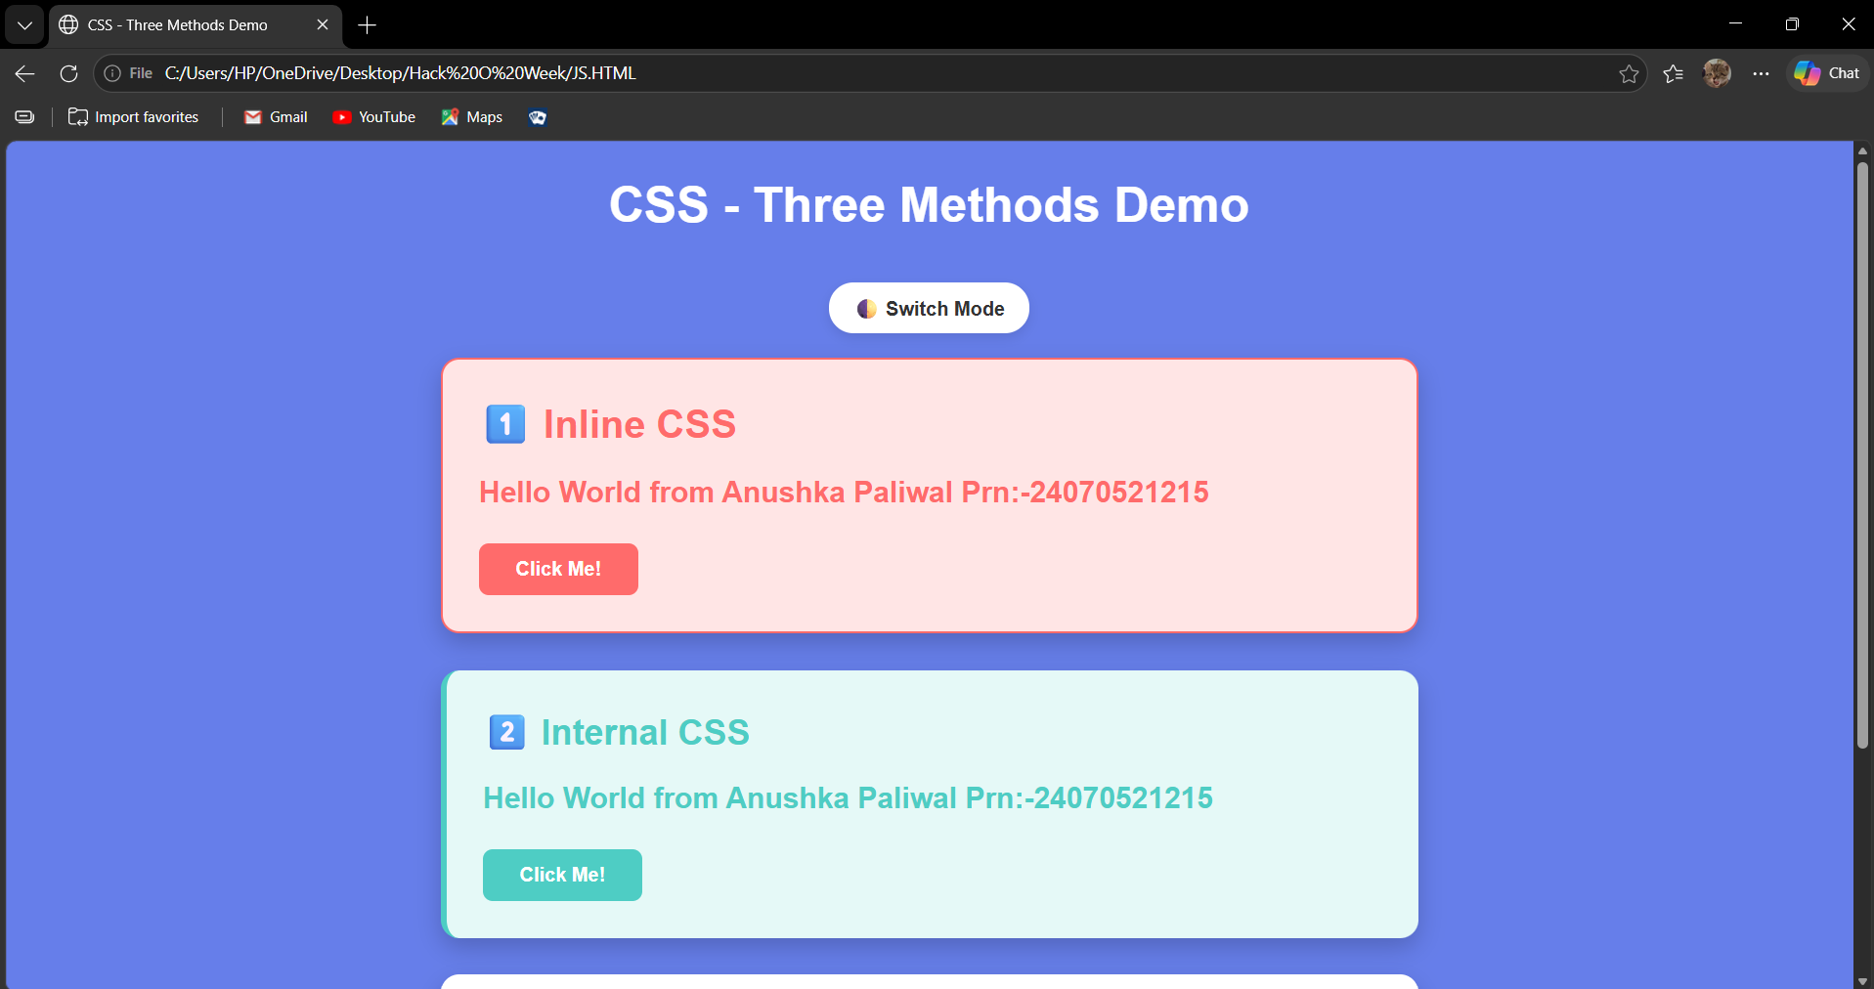
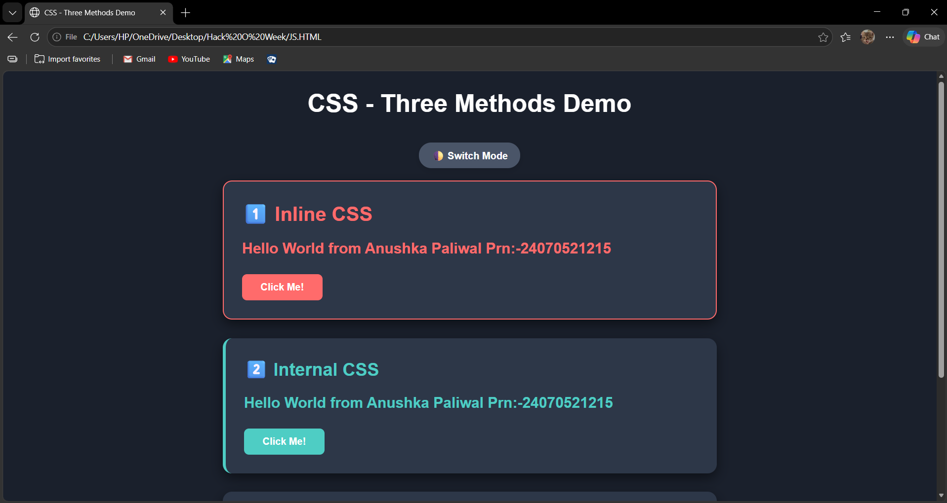
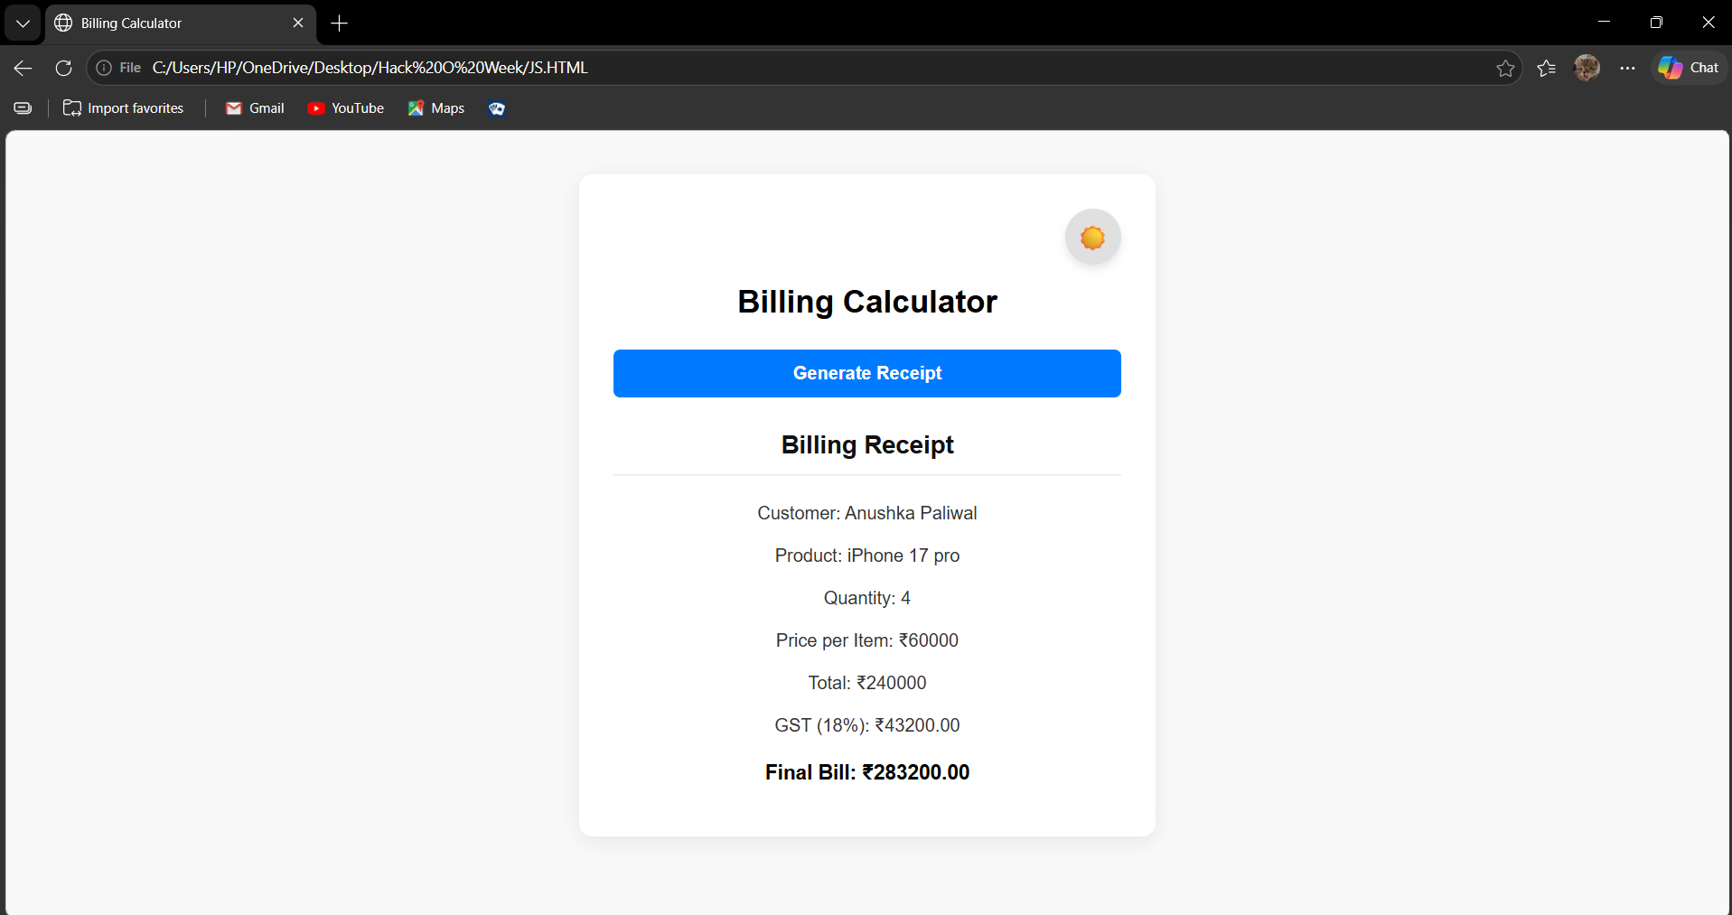
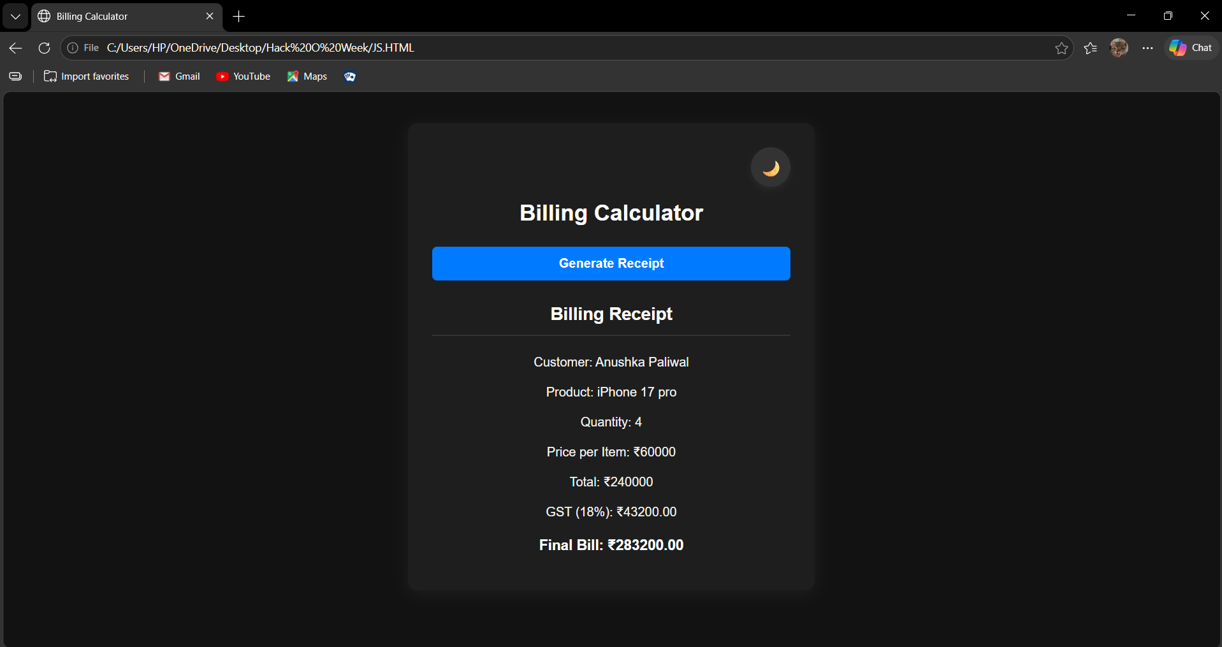
RESULT / CONCLUSION:
Operational Outcome: Successfully established a scalable theme-toggle framework that works seamlessly across external stylesheets, internal <style> rules, and stubborn inline attributes.
Lab Implementation: The system proves that applying an accessible black-and-white / dark mode across multiple heterogeneous web applications is achieved most reliably by binding state to document.body while programmatically handling hardcoded inline style overrides.
EXPERIMENT 10
AIM:
Load and display JSON data using fetch() and jQuery $.getJSON(); render results dynamically in a table.

SOFTWARE REQUIRED:
- Any text/code editor (e.g., VS Code)
- Web browser (e.g., Chrome, Edge, Firefox) to render the HTML page
- Basic knowledge of HTML5 and modern JavaScript (ES6+)

THEORY:
JSON:
JSON (JavaScript Object Notation) is a lightweight data-interchange format used to store and transfer data. It represents data in a simple key-value pair structure and is commonly used for communication between web applications and servers.
Fetch API:
The JavaScript fetch() API is used to request and retrieve data from external files or servers. It returns a Promise and can be used with .then() and .catch() to handle successful responses and errors.
jQuery $.getJSON():
jQuery provides the $.getJSON() method to load JSON data from a file or server. It simplifies the process of making an asynchronous request and processing the returned JSON data.
Dynamic Table Rendering:
Dynamic rendering is the process of creating and updating webpage elements using JavaScript. In this experiment, student records are dynamically converted into table rows and cells and inserted into the HTML table.

DOM Manipulation:
DOM manipulation allows JavaScript to access and modify HTML elements. Methods such as getElementById(), createElement(), innerHTML, and appendChild() are used to dynamically display the student information.

EXPERIMENT CONTEXT:
This experiment focuses on loading student data stored in a JSON file using two different approaches: JavaScript's fetch() API and jQuery's $.getJSON() method. The retrieved data contains student details such as Roll No., Name, Course, Year, Email, and Marks. The data is processed and dynamically displayed in an HTML table. The application also displays appropriate messages while loading the data and when an error occurs.

OUTPUT:
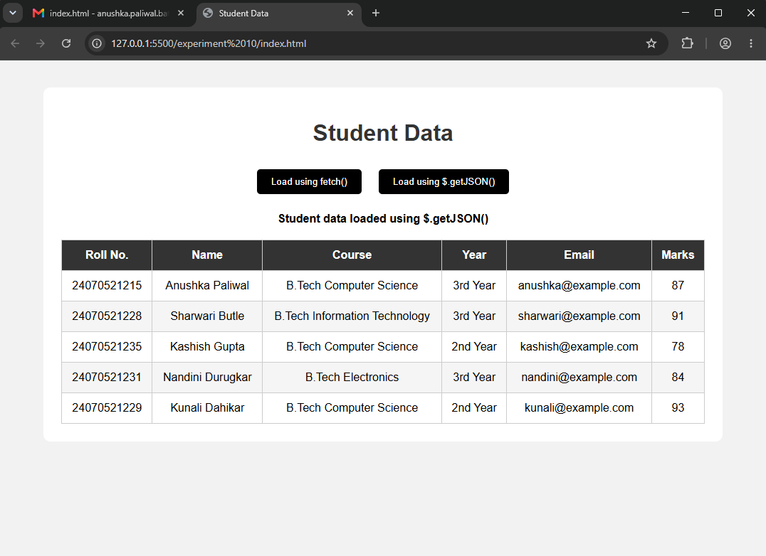

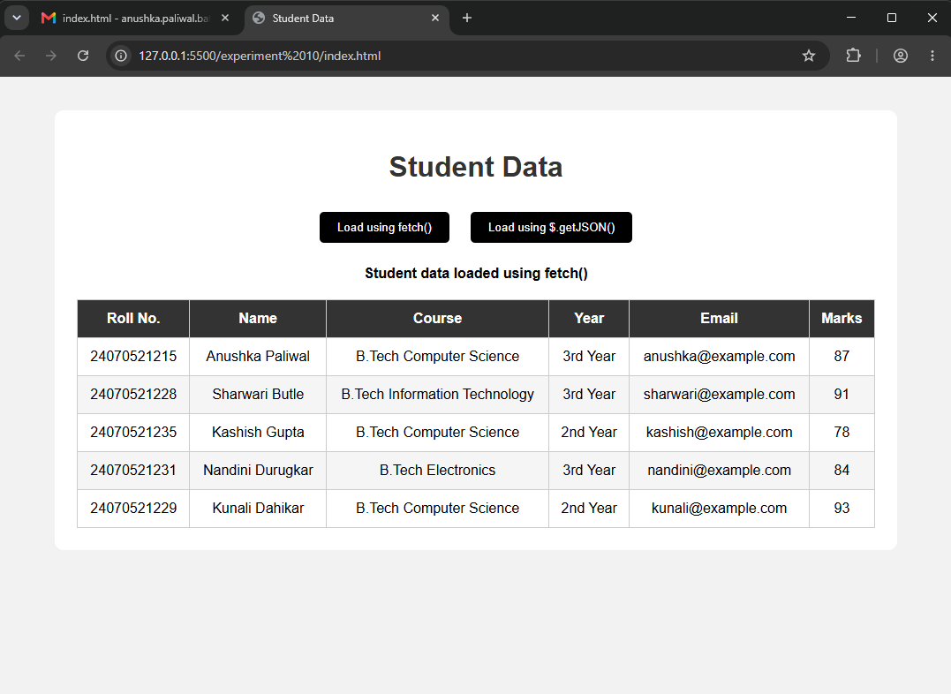

RESULT / CONCLUSION:
The experiment was successfully executed. It demonstrates the use of JSON data, JavaScript fetch(), jQuery $.getJSON(), asynchronous data loading, and DOM manipulation to retrieve and dynamically display student records in an HTML table.

CASE STUDY 10
TITLE:
Campus Event Student Registration Management System via AJAX, Fetch API, and jQuery

AIM:
To design and develop a responsive Student Registration Management System using HTML5, CSS3, JavaScript (Fetch API), and jQuery ($.getJSON()) to asynchronously fetch, parse, and render JSON datasets into an interactive data table with live multi-criteria filtering, statistical computation, and dark mode toggling.

THEORY:
Asynchronous Data Retrieval (AJAX vs. Fetch API vs. jQuery):
- Fetch API: Native modern ES6 promise-based interface. It returns a Response object requiring explicit status validation (response.ok) and parsing via response.json().
- jQuery $.getJSON(): An abstracted shorthand for $.ajax({ dataType: "json", ... }) that automatically parses the JSON payload into a native JavaScript object/array and exposes chainable .done() and .fail() deferred callbacks.
Declarative Multi-Condition Filtering:
- Uses Array.prototype.filter() combining string searching (includes() on case-normalized student names and PRNs) and categorical match (status === "All" || student.registrationStatus === status).
Dynamic Table & State Updates:
- Employs jQuery DOM injection (table.empty() followed by table.append()) to reconstruct rows without refreshing the page.
- Dynamically aggregates key performance indicators (Total, Registered, Pending, Cancelled) in real time using array length calculations.
Theme Switching with CSS Custom Properties:
- Uses root design tokens (--bg, --card, --text, --border) redefined under the body.dark class selector and toggled via jQuery's toggleClass("dark").

PROJECT DESCRIPTION:
The application is built as an interactive dashboard connecting client-side controllers to an external static JSON data source (students.json):
- Dual Asynchronous Ingestion Pipelines:
  - Button 1 (#fetchBtn): Executes native JavaScript fetch("students.json") with promise chaining (.then(), .catch()) and robust error logging.
  - Button 2 (#jqueryBtn): Executes jQuery's $.getJSON("students.json") demonstrating cross-library asynchronous data handling.
- Dynamic Live Controls & Search Engine:
  - An input listener (#searchInput) monitors keystrokes in real time to filter by student name or PRN.
  - A dropdown selector (#statusFilter) filters students by registration state (Registered, Pending, Cancelled).
- Statistical Summary Cards:
  - Four KPI cards at the top track total loaded students alongside breakdown counters that update on every filter cycle.
- Accessible Data Presentation & Status Highlighting:
  - Renders parsed data into a table with color-coded status badges (.registered, .pending, .cancelled).
  - Displays fallback messaging (empty state) if the query yields zero matching records.
- Theme Personalization:
  - A header toggle button switches between light and dark modes, updating both CSS variables and the button's label
CODE:
INDEX.HTML
<!DOCTYPE html>
<html lang="en">
<head>
<meta charset="UTF-8">
<meta name="viewport" content="width=device-width, initial-scale=1.0">

<title>Campus Event Registration</title>

<link rel="stylesheet" href="style.css">

<!-- jQuery -->
<script src="https://code.jquery.com/jquery-3.7.1.min.js"></script>
</head>

<body>

<div class="container">

<header>
<div>
<h1>🎓 Campus Event</h1>
<p>Student Registration Management System</p>
</div>

<button id="themeBtn">🌙 Dark Mode</button>
</header>

<section class="control-panel">

<button id="fetchBtn" class="primary-btn">
📥 Load Student Data
</button>

<button id="jqueryBtn" class="secondary-btn">
⚡ Load using jQuery
</button>

<div class="search-box">
<input
type="text"
id="searchInput"
placeholder="🔍 Search by Name or PRN..."
>
</div>

<select id="statusFilter">
<option value="All">All Status</option>
<option value="Registered">Registered</option>
<option value="Pending">Pending</option>
<option value="Cancelled">Cancelled</option>
</select>

</section>

<div id="message" class="message">
Click <b>Load Student Data</b> to display registrations.
</div>

<section class="stats">

<div class="stat-card">
<span>👨‍🎓</span>
<div>
<h3 id="totalCount">0</h3>
<p>Total Students</p>
</div>
</div>

<div class="stat-card">
<span>✅</span>
<div>
<h3 id="registeredCount">0</h3>
<p>Registered</p>
</div>
</div>

<div class="stat-card">
<span>⏳</span>
<div>
<h3 id="pendingCount">0</h3>
<p>Pending</p>
</div>
</div>

<div class="stat-card">
<span>❌</span>
<div>
<h3 id="cancelledCount">0</h3>
<p>Cancelled</p>
</div>
</div>

</section>

<section class="table-card">

<div class="table-header">
<h2>📋 Student Registrations</h2>
<span id="resultCount">0 Results</span>
</div>

<div class="table-container">

<table>
<thead>
<tr>
<th>Student Name</th>
<th>PRN</th>
<th>Department</th>
<th>Year</th>
<th>Event Name</th>
<th>Status</th>
</tr>
</thead>

<tbody id="studentTable">
<tr>
<td colspan="6" class="empty">
No student data loaded.
</td>
</tr>
</tbody>

</table>

</div>

</section>

<footer>
JSON File → Fetch / $.getJSON() → Parse Data → JavaScript / jQuery → HTML Table
</footer>

</div>

<script src="script.js"></script>

</body>
</html>

SCRIPT.JS
let students = [];

// ================================
// FETCH API
// ================================

$("#fetchBtn").click(function () {

fetch("students.json")
.then(response => {

if (!response.ok) {
throw new Error("JSON file could not be loaded");
}

return response.json();
})

.then(data => {

students = data;

displayStudents(students);

$("#message").html(
"✅ Student data loaded successfully using <b>JavaScript Fetch API</b>."
);

})

.catch(error => {

$("#message").html(
"❌ Error: Unable to load students.json"
);

console.error(error);
});

});

// ================================
// jQUERY getJSON()
// ================================

$("#jqueryBtn").click(function () {

$.getJSON("students.json")

.done(function (data) {

students = data;

displayStudents(students);

$("#message").html(
"⚡ Student data loaded successfully using <b>jQuery $.getJSON()</b>."
);

})

.fail(function () {

$("#message").html(
"❌ Error: Unable to load students.json"
);

});

});

// ================================
// DISPLAY STUDENTS
// ================================

function displayStudents(data) {

const table = $("#studentTable");

table.empty();

if (data.length === 0) {

table.html(`
<tr>
<td colspan="6" class="empty">
😕 No student matches the search/filter criteria.
</td>
</tr>
`);

} else {

data.forEach(student => {

let statusClass =
student.registrationStatus.toLowerCase();

table.append(`

<tr>

<td>
<b>${student.studentName}</b>
</td>

<td>${student.PRN}</td>

<td>${student.department}</td>

<td>${student.year}</td>

<td>${student.eventName}</td>

<td>
<span class="status ${statusClass}">
${student.registrationStatus}
</span>
</td>

</tr>

`);

});

}

updateStats();
$("#resultCount").text(data.length + " Results");
}

// ================================
// SEARCH + FILTER
// ================================

function filterStudents() {

const search =
$("#searchInput").val().toLowerCase();

const status =
$("#statusFilter").val();

const filtered = students.filter(student => {

const matchesSearch =
student.studentName.toLowerCase().includes(search) ||
student.PRN.toLowerCase().includes(search);

const matchesStatus =
status === "All" ||
student.registrationStatus === status;

return matchesSearch && matchesStatus;

});

displayStudents(filtered);

if (filtered.length === 0 && students.length > 0) {

$("#message").html(
"⚠️ No student matches the search/filter criteria."
);

} else if (students.length > 0) {

$("#message").html(
`Showing <b>${filtered.length}</b> matching student(s).`
);
}
}

// Search

$("#searchInput").on("input", function () {
filterStudents();
});

// Status filter

$("#statusFilter").change(function () {
filterStudents();
});

// ================================
// STATISTICS
// ================================

function updateStats() {

$("#totalCount").text(students.length);

$("#registeredCount").text(
students.filter(
s => s.registrationStatus === "Registered"
).length
);

$("#pendingCount").text(
students.filter(
s => s.registrationStatus === "Pending"
).length
);

$("#cancelledCount").text(
students.filter(
s => s.registrationStatus === "Cancelled"
).length
);
}

// ================================
// DARK / LIGHT MODE
// ================================

$("#themeBtn").click(function () {

$("body").toggleClass("dark");

if ($("body").hasClass("dark")) {

$(this).text("☀️ Light Mode");

} else {

$(this).text("🌙 Dark Mode");

}

});

STUDENTS.JSON
[
{
"studentName": "Anushka Paliwal",
"PRN": "24070521215",
"department": "Computer Science",
"year": "3rd Year",
"eventName": "Tech Fest",
"registrationStatus": "Registered"
},
{
"studentName": "Sharwari Butle",
"PRN": "24070521228",
"department": "Information Technology",
"year": "2nd Year",
"eventName": "Hackathon",
"registrationStatus": "Pending"
},
{
"studentName": "Nandini Durugkar",
"PRN": "24070521231",
"department": "Artificial Intelligence",
"year": "3rd Year",
"eventName": "AI Workshop",
"registrationStatus": "Registered"
},
{
"studentName": "Rahul Sharma",
"PRN": "24070521245",
"department": "Computer Science",
"year": "4th Year",
"eventName": "Coding Contest",
"registrationStatus": "Cancelled"
},
{
"studentName": "Priya Patil",
"PRN": "24070521256",
"department": "Electronics",
"year": "2nd Year",
"eventName": "Robotics Expo",
"registrationStatus": "Pending"
}
]

STYLE.CSS
* {
margin: 0;
padding: 0;
box-sizing: border-box;
}

:root {
--bg: #f4f7fb;
--card: #ffffff;
--text: #1e293b;
--muted: #64748b;
--border: #e2e8f0;
--primary: #6366f1;
--primary2: #8b5cf6;
}

body {
font-family: Arial, sans-serif;
background: var(--bg);
color: var(--text);
min-height: 100vh;
transition: 0.3s;
}

body.dark {
--bg: #0f172a;
--card: #1e293b;
--text: #f8fafc;
--muted: #94a3b8;
--border: #334155;
}

.container {
width: 92%;
max-width: 1250px;
margin: 35px auto;
}

/* HEADER */

header {
background: linear-gradient(
135deg,
var(--primary),
var(--primary2)
);

color: white;
padding: 30px;
border-radius: 20px;

display: flex;
justify-content: space-between;
align-items: center;

box-shadow: 0 15px 35px rgba(79, 70, 229, 0.25);
}

header h1 {
font-size: 32px;
margin-bottom: 7px;
}

header p {
opacity: 0.85;
}

#themeBtn {
border: none;
padding: 12px 18px;
border-radius: 10px;
cursor: pointer;
font-weight: bold;
background: white;
color: #4f46e5;
}

/* CONTROL PANEL */

.control-panel {
background: var(--card);
padding: 20px;
margin-top: 22px;

border: 1px solid var(--border);
border-radius: 16px;

display: flex;
gap: 12px;
flex-wrap: wrap;
}

button,
select,
input {
font-size: 15px;
}

.primary-btn,
.secondary-btn {
border: none;
padding: 13px 18px;
border-radius: 10px;
cursor: pointer;
font-weight: bold;
}

.primary-btn {
background: var(--primary);
color: white;
}

.secondary-btn {
background: #10b981;
color: white;
}

.search-box {
flex: 1;
min-width: 230px;
}

.search-box input {
width: 100%;
height: 45px;
padding: 0 15px;

border: 1px solid var(--border);
border-radius: 10px;

background: var(--bg);
color: var(--text);
}

select {
padding: 0 15px;
border: 1px solid var(--border);
border-radius: 10px;

background: var(--bg);
color: var(--text);
}

/* MESSAGE */

.message {
margin-top: 18px;
padding: 15px 18px;

background: var(--card);
border-left: 5px solid var(--primary);

border-radius: 10px;
color: var(--muted);
}

/* STATS */

.stats {
display: grid;
grid-template-columns: repeat(4, 1fr);
gap: 15px;
margin-top: 20px;
}

.stat-card {
background: var(--card);
border: 1px solid var(--border);

padding: 20px;
border-radius: 15px;

display: flex;
align-items: center;
gap: 15px;
}

.stat-card > span {
font-size: 30px;
}

.stat-card h3 {
font-size: 25px;
}

.stat-card p {
color: var(--muted);
font-size: 13px;
}

/* TABLE */

.table-card {
margin-top: 22px;

background: var(--card);
border: 1px solid var(--border);

border-radius: 18px;
overflow: hidden;
}

.table-header {
padding: 20px;

display: flex;
justify-content: space-between;
align-items: center;

border-bottom: 1px solid var(--border);
}

.table-header h2 {
font-size: 21px;
}

.table-header span {
color: var(--muted);
}

.table-container {
overflow-x: auto;
}

table {
width: 100%;
border-collapse: collapse;
}

th {
background: rgba(99, 102, 241, 0.1);
color: var(--primary);
text-align: left;
padding: 16px;
}

td {
padding: 16px;
border-bottom: 1px solid var(--border);
}

tr:hover {
background: rgba(99, 102, 241, 0.05);
}

.status {
padding: 7px 12px;
border-radius: 20px;
font-size: 12px;
font-weight: bold;
}

.registered {
background: #dcfce7;
color: #15803d;
}

.pending {
background: #fef3c7;
color: #b45309;
}

.cancelled {
background: #fee2e2;
color: #dc2626;
}

.empty {
text-align: center;
padding: 40px;
color: var(--muted);
}

/* FOOTER */

footer {
text-align: center;
margin: 25px 0;
color: var(--muted);
font-size: 13px;
}

/* RESPONSIVE */

@media (max-width: 850px) {
.stats {
grid-template-columns: repeat(2, 1fr);
}
}

@media (max-width: 600px) {

.container {
width: 95%;
}

header {
flex-direction: column;
gap: 20px;
text-align: center;
}

.stats {
grid-template-columns: 1fr;
}

.control-panel {
flex-direction: column;
}

.search-box {
width: 100%;
}

select {
height: 45px;
}
}

OUTPUT:
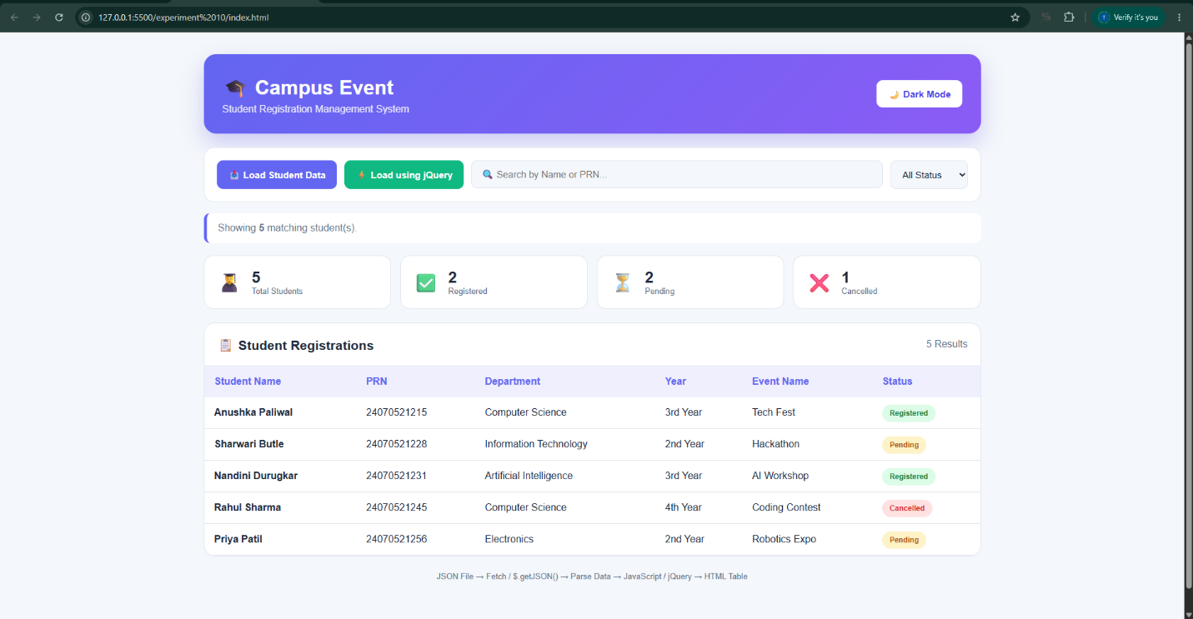

RESULT/CONCLUSION:
Operational Status: Successfully implements asynchronous client-server communication using both vanilla JavaScript Fetch and jQuery AJAX. Data ingestion, dynamic table binding, live multi-attribute filtering, and real-time statistics run with zero page reloads.
Key Takeaway: Demonstrates real-world front-end data handling: consuming structured REST/JSON endpoints, managing local memory state, and using jQuery alongside modern CSS custom properties.

